ST. XAVIER’S COLLEGE

MAITIGHAR, KATHMANDU, NEPAL

Phone: 01-5321365, 01-5344636

Email: ktm@sxc.edu.np



Assignment Number: 15

“Design of Computer syllabus, question & solution”

|  |  |  |
| --- | --- | --- |
| Submitted by | Submitted to | Signature |
| Name: Pratik Bajracharya  Roll No.:934  Class:11  Section: I | Ms. Jamuna Maharjan  Department of Computer Science (+2),  St Xavier’s College |  |

Submission Date: 20th March, 2025

Table of Contents

Code for Website 3

File: Menu.html 3

File: styl.css 4

File: chapter1.html 6

File: chapter2.html 11

File: chapter3.html 14

File: chapter4.html 20

File: chapter5.html 26

File: chapter6.html 32

File: chapter7.html 38

File: chapter8.html 42

File: Question & Answers.html 45

CONCLUSION 52

# Code for Website

## File: Menu.html

<html>

    <head>

        <link rel="stylesheet" href="styl.css">

        <style>

        </style>

        <title>MENU</title>

    </head>

    <body>MENU

        <nav>

            <a href="Chapter1.html">Chapter 1</a>

            <a href="Chapter2.html">Chapter 2</a>

            <a href="Chapter3.html">Chapter 3</a>

            <a href="Chapter4.html">Chapter 4</a>

            <a href="Chapter5.html">Chapter 5</a>

            <a href="Chapter6.html">Chapter 6</a>

            <a href="Chapter7.html">Chapter 7</a>

            <a href="Chapter8.html">Chapter 8</a>

        </nav>

    </body>

</html>

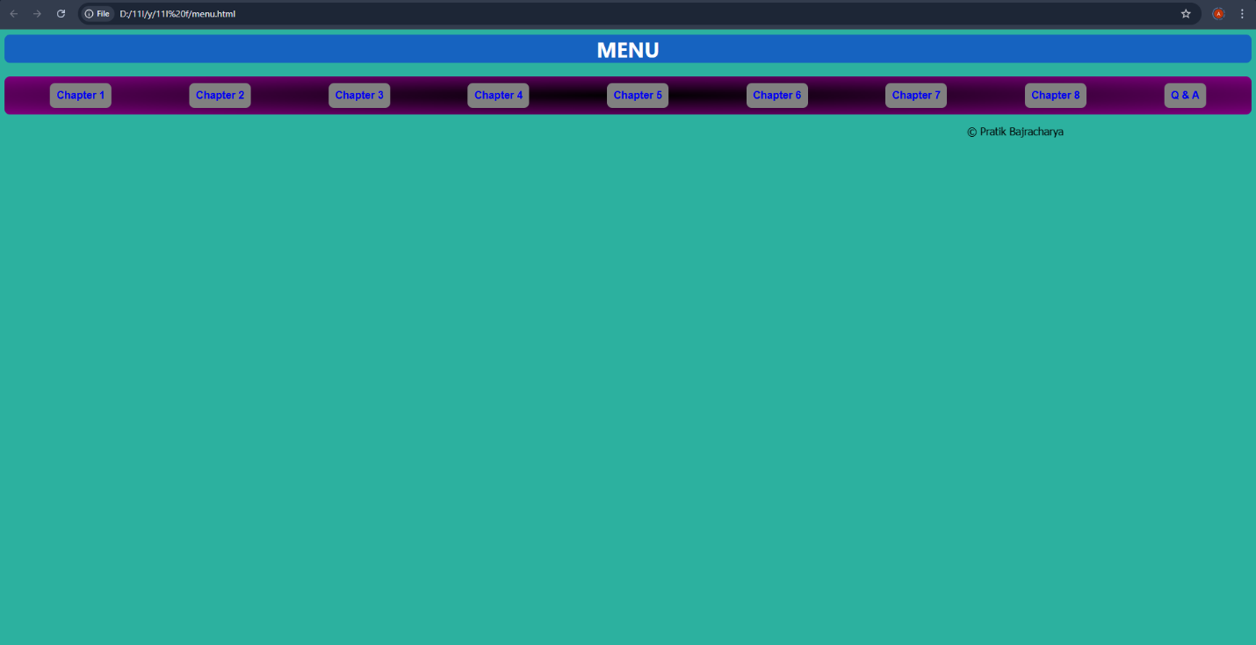**OUTPUT:**

## File: styl.css

body{

    background-color: rgb(186, 167, 203);

}

nav{

    background-image: radial-gradient(black, purple);

    font-family: Arial;

    display: flex;

    justify-content: space-around;

    padding: 10px;

    border-radius: 8px;

    text-align: center;

    font-weight: bolder;

    position: sticky;

    top: 0px;

}

nav a{

    background-color: grey;

    padding:10px;

    border-radius:8px;

}

nav a[href="#"]{

color:red;

background-color: rgb(22, 99, 192);

width: 80px;

text-align: center;

height: 20px;

padding: 10px;

}

nav a:hover{

    background-color:bisque;

    padding: 10px;

}

nav a{

    text-decoration: none;

}

h1{

    font-family:system-ui, -apple-system, BlinkMacSystemFont, 'Segoe UI', Roboto, Oxygen, Ubuntu, Cantarell, 'Open Sans', 'Helvetica Neue', sans-serif;

    color:chocolate;

    text-align: center;

    color: white;

}

div{

    background-color: rgb(22, 99, 192);

    border-radius: 8px;

}

p{

  font-family: Tahoma;

}

h3,h2{

    font-family: Tahoma;

}

## File: chapter1.html

<html>

    <head>

        <link rel="stylesheet" href="styl.css">

        <title>Chapter 1</title>

    </head>

    <body><h1><div>MENU</div></h1>

        <nav>

            <a href="#">Chapter 1</a>

            <a href="Chapter2.html">Chapter 2</a>

            <a href="Chapter3.html">Chapter 3</a>

            <a href="Chapter4.html">Chapter 4</a>

            <a href="Chapter5.html">Chapter 5</a>

            <a href="Chapter6.html">Chapter 6</a>

            <a href="Chapter7.html">Chapter 7</a>

            <a href="Chapter8.html">Chapter 8</a>

        </nav>

        <div><h1>Chapter 1 : Computer System</h1></div>

        <p>

            Computer is an electronic device device derived from the Latin word "computere" which means to calculate. It accepts raw facts and figures as an input which are isolated and uninterpreted through input device, process it according to the requirement of the user or command supplied by the user, store it before and after processing of require and produce a meaningful information as an output through an output device. Generally, computer works on IPO (Input-Process-Output) cycle. It follows GIGO (Garbage In Garbage Out) algorithm which means the output is always based on the input supplied by the user. The basic operation of computer is illustrated by following block diagram.

        </p>

        <h2>Some characteristics/features of computer.</h2>

            <p>The implementation of computers are not only limited/confined to a small area rather they are used from simple domestic task to complex scientific research to engineering. The use of computer are increasing day-by-day due to some special features or characteristics that computer own. Several features of computer are:

            Accuracy: Computer are the accurate machine that means result produced by computer are 100% accurate. Since, it follows GIGO. The error that may arise in output is due to human not by a computer.

            Speed: Computer works on tremendously high speed. The operating speed of computer are measured in  millisecond, microsecond, picosecond and nanosecond which means computer can perform millions and billions of instruction per second.

            Storage: It is the area or unit which is capable of storing data and information for present and future use. Storing data allows users to retrieve it whenever required. These days computer comes with high volume of memory which are measured in Megabyte (1024 KB) , Gigabyte (1024 MB), Terabyte(1024 GB) and Petabyte(1024 TB).

            Versatility: Computer are generally design to serve more than one type of work. The implementation of computer are not only limited to specific purpose, they solve general requirement of the user and can be used in more than 1 type of job.

            Diligence: The feature of computer in which computer doesn't get tired even after working for long period of time. Computer can perform any number of task continuously until it is accomplished. Once the instruction is given computer follows the command till it gets terminated.

            Automatic: Computer is an automatic machine. Once the instruction is generated it perform accordingly until command is terminated. We don't have to issue continuous command in order to operate the computer. This is called automatic.</p>

<h2>Applications/Implementations/Uses of computer</h2>

<p>

    The uses of computer are increased day by day. Every aspect if human life is highly influenced by computer. From simple domestic use to complex engineering and scientific solutions, computer can be used. This is due to the versatility of computer. Some of the basic implementation of computer are:

Education: Nowadays, computer are highly used in teaching and learning process. Many interesting graphics can be made and provided for easy learning. Also, computer provide features of internet which make learning easy and fun.

Communication: Computer is massively used in communication. Communication is done by e-mail, chat, online conferencing. e-fax etc with help of internet in computer. It has made the communication faster, easier and cheaper.

Business: In business sector, computer are used to generate invoice, maintain stock and make statistical analysis. E-commerce is the new and emerging way of buying and selling goods and service through used of electronic means and media.

Engineering and designing: Scientific and engineering design requires complex and massive computations. Design of bridges, towers, buildings, generators, motors, electrical transmission etc requires precise computation which are done through computers.

Science and research

Military

Industry

Medicine

Robotics

Transportation</p>

<h2>Generations of computer.</h2>

<p>

    History of computers dates back to mechanical era where computer were not used for general purpose. It takes long period of time to come to this phase. Development of computer had passed through different era from mechanical to electro mechanical to digital computer. The development in different electronic components, precise engineering and hi-tech technology has change the operation of computer drastically. Earlier computer were only used for specific purpose such as counting and performing basic mathematical operation. Later on, due to the necessity and requirement of user different general purpose computer were developed. Therefore, the classification of computer on the basis of major electronic component, their architecture and modes of operation is known as generations of computer. Five different generations of computer are listed below along with their distinct features.

    <br>

   <h3> 1. First generations computer (1946-1958 )</h3>

    <p>They used vacuum tubes as their basic electronic components used to control and amplify electronic signals.

    They were big in size, consume more electricity and generate large amount of heat thus required air conditioning system to keep device cool.

    They were unreliable and were prone to frequent hardware failure.

    They were normally not used for commercial purpose.

    Machine level language was used to program these computers.

    eg: ENIAC, EDVAC, EDSAC, UNIVAC<br></p>

    <h3>2. Second generations computer (1959-1964 )</h3>

    <p>They used transistors as their basic electronic components.

    They were small in size as compared to first generation thus consume less electricity and generate less heat.

    They were less prone to hardware failure thus more reliable.

    They were not also for commercial purpose because production was difficult and costly.

    Assembly language were used to program these computers.

    eg: IBM 7000, IBM 1401, IBM 1620, NCR 304, MARK III, ATLAS<br></p>

    [Note: First computer brought in Nepal was IBM 1401 for population census of 2028 BS]

     <br>

     <h3>3.Third generations computer ( 1965-1974 )</h3>

    <p>They used Integrated Circuits (IC) as their basic electronic components.

    They were smaller in size, consume less electricity and generate less amount of heat.

    They were faster and more reliable compared to first and second generations.

    They were widely used for the commercial application all over the world.

    High level language were used to program these computers.

    eg: PDP-8, PDP-11, ICL 2900 series, IBM 360, IBM 370</p>

    <h3>4. Fourth generation computer (1975-1990)</h3>

<p>They use VLSI ( Very Large Scale Integrated Circuits ) as their main electronic components.

    There size were drastically reduced and hence were they were much more portable.

    They were faster in processing and were much more reliable.

    They have larger memory up to GB and TB.

    They use different advance high level language to program this computer.

    eg: Apple Macintosh,  IBM PC<br></p>

    <h3>5. Fifth generation computer (1990-onwards)</h3>

<p>They use ULSIC (Ultra Large Scale Integrated Circuit) or Microprocessor as their major electronic components.

    They have or will have artificial intelligence.

    They have tremendously high processing unit due to parallel processing.

    They are capable of image processing, speech or voice recognition.

    They use different high level language to program this computer.</p></p>

<p><marquee>&copy; Pratik Bajracharya</marquee></p>

    </body>

</html>

**OUTPUT:**

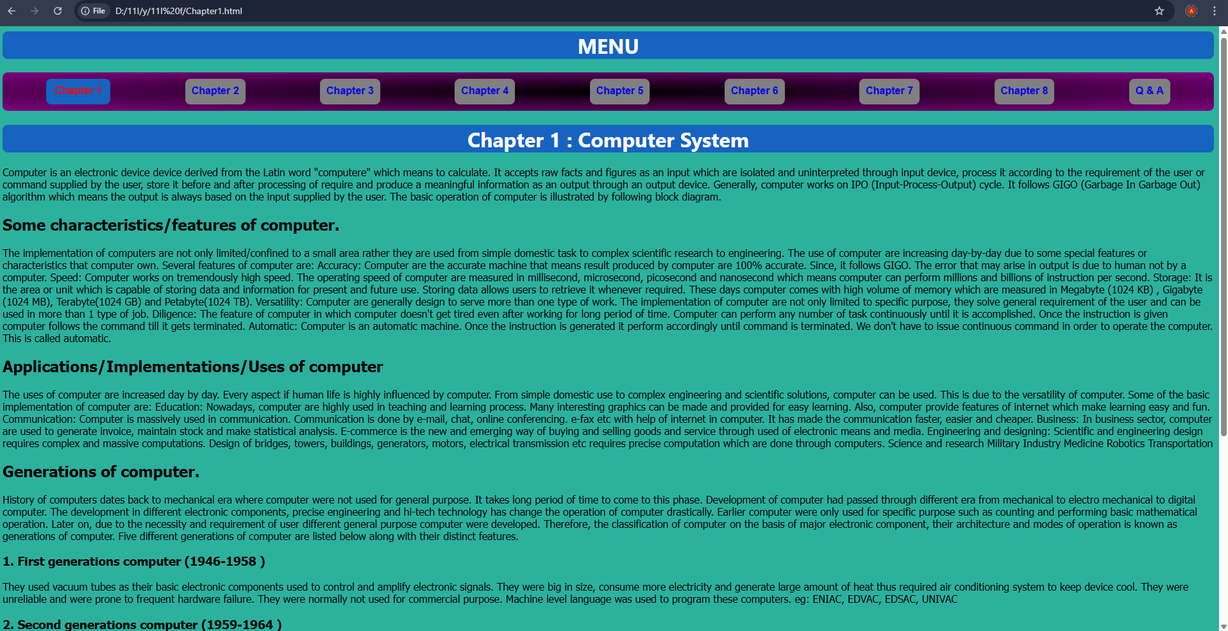

## File: chapter2.html

<html>

    <head>

        <link rel="stylesheet" href="styl.css">

        <title>Chapter 2</title>

    </head>

    <body><h1><div>MENU</div></h1>

        <nav>

            <a href="Chapter1.html">Chapter 1</a>

            <a href="#">Chapter 2</a>

            <a href="Chapter3.html">Chapter 3</a>

            <a href="Chapter4.html">Chapter 4</a>

            <a href="Chapter5.html">Chapter 5</a>

            <a href="Chapter6.html">Chapter 6</a>

            <a href="Chapter7.html">Chapter 7</a>

            <a href="Chapter8.html">Chapter 8</a>

        </nav>

        <div><h1>Chapter 2 : Number System and Conversion Boolean Logic</h1></div>

        <h3>1's and 2's Complement</h3>

        <p> 1's Complement: Reciprocal of 1s to 0s and 0s to 1s is its 1's complement. For eg, 1's Complement of (1011)2 is (0100)2

            2's Complement: Adding 1 to the 1's complement of a given binary number is its 2's complement.

            For eg, if (1010)2 is a given number then, its

            1's complement is (0101)2 and 2's complement is (0101)2 +(1)2 = (0110)2</p>

            <h3>Introduction: Boolean Logic</h3>

<p>Boolean Algebra is algebra of logic, which deals with the study of binary variables and logical operation. As every data are represented in terms  binary values, we need to manipulate those values by using some certain rules and expression which we can do through Boolean algebra. It is most common and basic method to analysis and design logic circuit. It was introduced by an English mathematician George Boole. In Boolean algebra the variables can have only one of the two possible value 0 and1 (False or True). Every modern digital computers understand either this two values.

Boolean algebra: It is algebra of logic which could accept either of the possible two values 0 and 1 and generate a result through logical relationship and operation.

Boolean variable: Those entities which has either or 0 and 1 and denote some specific operation ore known as boolean variable. Simply, it is an entity in Boolean algebra which has only either of the two possible values. This variable are denoted by A, B, P, Q, X, Y, Z….

Boolean function (logic functions): Boolean function is an expression formed by binary variables, binary operators such as AND, OR, NOT, parentheses, and equal sign for a given set of value this boolean function gives the 0 or 1 as a result.

let us consider,

F = XYZ’+XY

Where, F is a boolean function

X, Y, Z are a boolean variable.

X, Y, Z, Z’ are also literals.

Truth Table: A table which represents the input-output  relationship between of the binary variables for each logical gate called truth table. It shows the relationship between input and output in tabular form. Thus, truth table is table representing the results the logical operation of the logical operation on all possible combination of logical values.

Boolean Operator and Operands

Operators are the symbols that define the specific operation. These are three basic operators used in Boolean Algebra, ie. AND, OR, NOT. Every other operations can be expressed in terms of this basic operation. For examples, NOR operator is the combination of NOT and OR operators.</p>

<h3>Logic Gate</h3>

<p>A logic Gate is an electronic circuit that operates on one or more inputs to produce an output. Logic Gate are used for binary operations which are very fundamental components for modern digital computer. Logic gates are embedded unit an Integrated Circuit (IC). Each gate has its specific function and graphical symbol. In digital computer there are three basic logic gates.</p>  
<p><marquee>&copy; Pratik Bajracharya</marquee></p>

    </body>

</html>

**OUTPUT:**

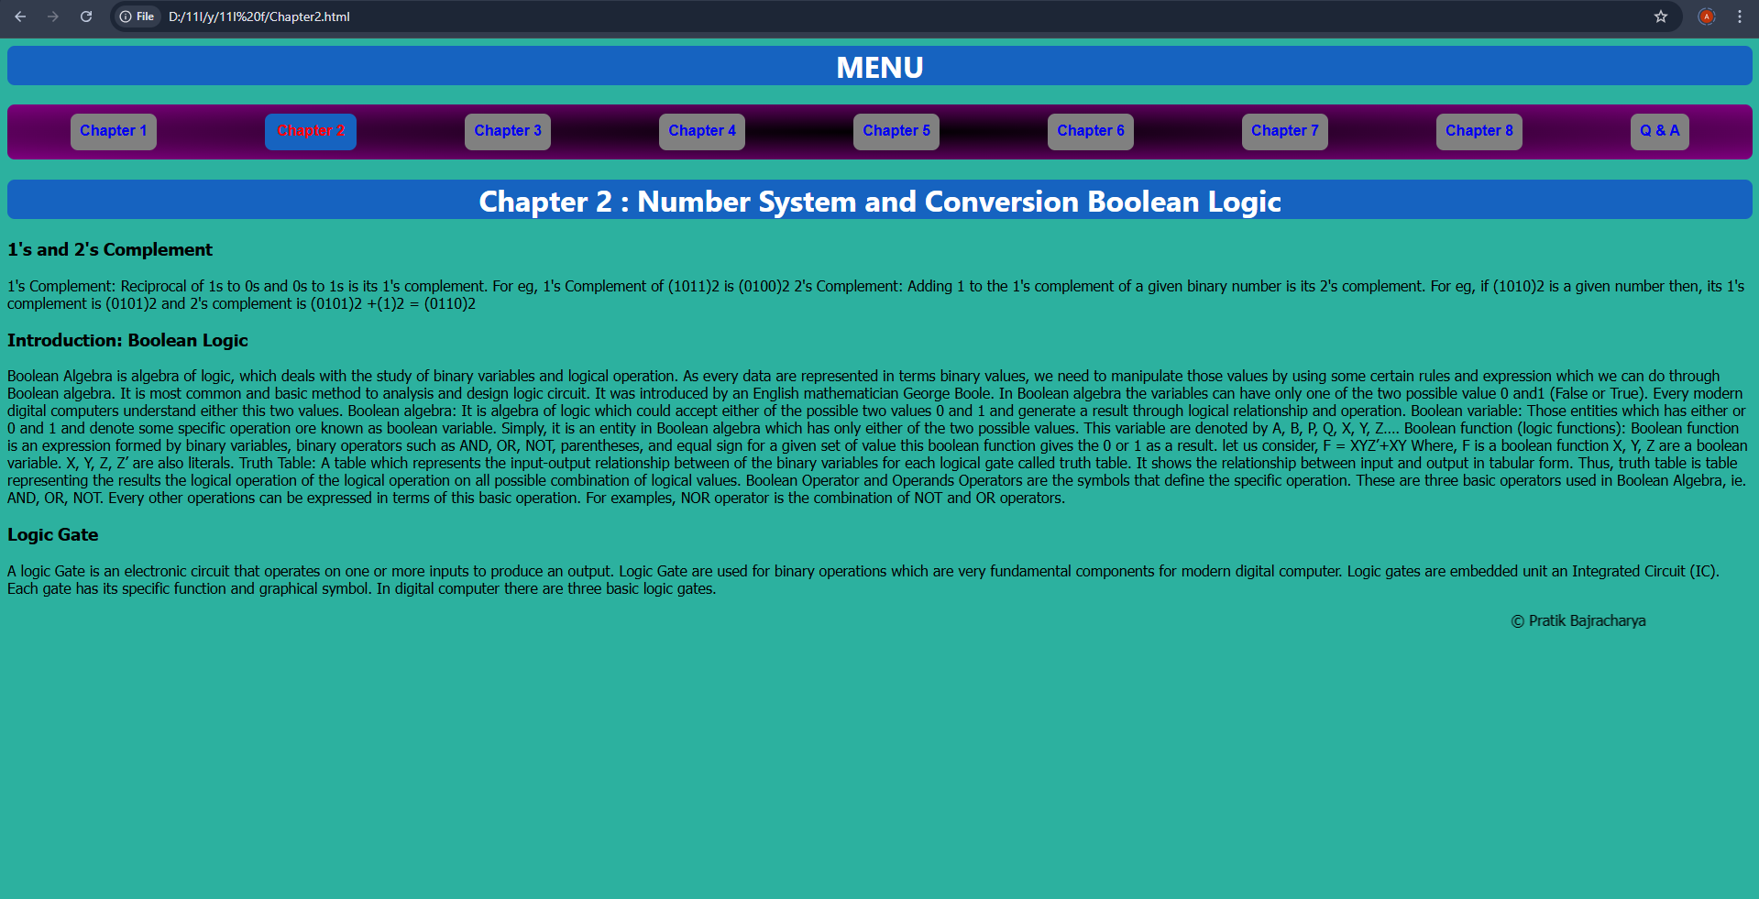

## File: chapter3.html

<html>

    <head>

        <link rel="stylesheet" href="styl.css">

        <title>MENU</title>

    </head>

    <body><h1><div>MENU</div></h1>

        <nav>

            <a href="Chapter1.html">Chapter 1</a>

            <a href="Chapter2.html">Chapter 2</a>

            <a href="#">Chapter 3</a>

            <a href="Chapter4.html">Chapter 4</a>

            <a href="Chapter5.html">Chapter 5</a>

            <a href="Chapter6.html">Chapter 6</a>

            <a href="Chapter7.html">Chapter 7</a>

            <a href="Chapter8.html">Chapter 8</a>

        </nav>

        <div><h1>Chapter 3 : Computer software and Operating system</h1></div>

        <p><h2>Software - Introduction:</h2></p>

        <p>As we know stand alone hardware cannot do nothing, for the smooth operation of our Computer System there should be proper coordination between hardware and software. Software helps to mobilize the hardware and other resources. In order to mobilize hardware we have to write several set of instruction which instruct computer what to do, what not o. These set of instruction are collectively know as program and the term software is the collection of related programs and  associated documents. In Order to produce useful output, hardware and software must work together. Nothing useful can be done with the hardware only and software cannot be utilize without hardware. The different types of software are:</p>

        <p><h2>System software:</h2></p>

        <p>System software is set of one or more programs designed to control the operation of our computer system. This type of software doesn't fulfill the specific requirement of the user. They are general program written to assist human in the use of the computer system. In general system software support the running of other software, communicate with peripheral device, support the development of other types of software and monitors the use of various hardware resources. Thus, the system software makes the operation of the computer system more effective and efficient. The system software is categorized into two categories.</p>

        <p><h2>System Management:</h2></p>

        <p>It is responsible for proper management and functioning of the computers system. All types of management between computer hardware and software is performed by system management software. There are 3 types of system management software:</p>

        <p><h2>Operating System:</h2></p>

        <p>Operating system is a collection program that controls the overall operation of the computer system. It is the 1st program that is loaded into memory when the computer is turned on. It provides platform for other application program to run and execute. It provides user with an interface so that uses can easily communicate with computer. For example Linux, Windows, Mac etc.</p>

        <p><h2>Utility software:</h2></p>

        <p>It is the supporting software which is used to perform specific task related to the maintenance of the computer system. Some  of the utility software are included in operating system where as some are available as separate utility in market. They are also called service program. For example  Norton Utility, PC tools, win zip etc.</p>

        <p><h2>Device driver:</h2></p>

        <p>A device driver is a software which is responsible for smooth functioning of the hardware device that is connected to the computer. When we add a new  device to the computer, we need to install new software called device driver. Device driver will co-ordinate with the operating system and the newly installed hardware functions properly and smoothly.</p>

        <p><h2>System Development:</h2></p>

        <p>It refers to set of programs that are use to develop computer program. This type of software are not used by a normal user of the computes. They are used by programmers for the development of new program. There are two types of system development software:</p>

        <p><h2>Programming language:</h2></p>

        <p>The language with which we give instruction to the computer is known as programming language. Programming language are the set of different keywords, variable, operators, loops and other symbols etc. They help to make communication between computer and user. These are two types of programming language low level language and high level language.</p>

        <p><h2>Language translator:</h2></p>

        <p>It is a special kind computer software which translates the programs written one language in another language. It is compulsory for both low and high level language. It is also called language processor. The types of language translator are compiler, interpreter  and assembler.</p>

        <p><h2>Application Software:</h2></p>

        <p>Application software is a set of one or more program which are design to do a specific task. It is made to fulfill the user demand. This program directs a computer to solve user oriented problem such as preparing bills,  calculating mathematical equation, preparing mark sheet etc. The software that are develop for user purpose is called application software. These types of software are generally develop by using high level language. For example Ms-Excel, Photoshop, Billing software etc. There are two types of application software:</p>

        <p><h2>Packaged software:</h2></p>

        <p>They are the generalized set of programs design and develop for general purpose. It is generally large sized, error-free, advance and standard software with much more functionality for special work. This type of software doesn't perfectly match the requirement of many organization or user. They cannot be changed easily are developed and designed by reputed software Company so they are trustworthy. They are expensive for small organization. For example Ms-Office, Adobe, Macromedia etc.</p>

        <p><h2>Customized / Tailored software:</h2></p>

        <p>This is a software developed in high level language for special task. This type of software is developed for some specific purpose for solving specific problem of specific user or organization. The requirement on the user or organization can be perfectly matched. They can be changed easily since they are made by local programmers. For example: payroll system, inventory management, school management, billing software, mark sheet evaluation etc.</p>

        <p><h1><div>Operating system - Introduction</div></h1></p>

        <p>An operating system (OS) is an integrated set of programs that controls overall resources such as CPU, memory, input-output devices of the computer system. The major objective of operating system is to improve the performance and efficiency of a computer system. Like the manager of a company, an operating system is responsible for the smooth and efficient functioning of the entire computer system. The operating system provides the platform for other application program/software to run and execute. It provides user with an interface so that user can easily communicate with computers, which is more convenient to use and operate.</p>

        <p><div><h1>Functions / Features / Advantages of Operating System (OS)</h1></div></p>

        <p><h2>Input-Output (I/O) Management:</h2></p>

        <p>Input-Output is essential to operate any computer. It allows computer to interact with several peripheral devices such as keyboard, mouse, printer, scanner etc.</p>

        <p><h2>User Interface (UI):</h2></p>

        <p>User Interface means an ideal environment in which user can work on it so that s/he can interact with the computerized system. Every operating system provides the feature of user interface in order to enhance the experience and joy of using computer or any other computerized system. It acts as a bridge between user and computer. There are 2 types of user Interface:</p>

        <p><h2>Character/Command User Interface (CUI):</h2></p>

        <p>Eg MS-DOS</p>

        <p><h2>Graphical User Interface (GUI):</h2></p>

        <p>Eg Windows, MAC OS</p>

        <p><h2>Security:</h2></p>

        <p>The operating system of a computer has a number of built-in tools to protect against security threats such as viruses, unauthorized access, suspicious network activity etc. The basic security in an OS is to control access to your computer by setting users and passwords.</p>

        <p><h2>Process Management:</h2></p>

        <p>The process management allocates a processor to execute a chosen process. OS acts as a traffic controller, job scheduler, process scheduler, and dispatcher.</p>

        <p><h2>Memory Management:</h2></p>

        <p>Memory is a large array of bytes, each with its own address. When the user requests CPU for read-write operation, OS determines the amount of memory required for the program instructions and data. Then OS allocates the required memory to load the program and data into RAM. When the program terminates, it frees up the space, and a new program is loaded.</p>

        <p><h2>Data Management:</h2></p>

        <p>Data management allows organizing their data into logical grouping called files. Earlier Operating systems did not provide features of data management. Hence, they were inflexible, but nowadays, every operating system provides this feature.</p>

        <p><h2>Command Interpreter:</h2></p>

        <p>The command interpreter reads the command that a user types in at a terminal, interprets them, and translates them into a detailed set of instructions that computer hardware can understand. Every operating system must have a command interpreter for its operation.</p>

        <p><h2>Dead-Lock Prevention:</h2></p>

        <p>During processing a situation can arise in which a resource shared by two or more processes cannot continue because the resources required by a process are held by another. This situation is known as deadlock. For eg. If process-1 allocates resources A and later requires resources B, and process-2 allocates resources B and later requires resources A. In this situation, neither process-1 nor process-2 will be executed. Such a situation is called deadlock. Operating systems ensure prevention of deadlock by taking action by careful allocation of resources.</p>

        <p><h2>Time Sharing:</h2></p>

        <p>The function of OS that involves the CPU allocating time to a number of users on the same computer. This property is generally found in network operating systems such as Windows NT.</p>

        <p><h2>Virtual Memory:</h2></p>

        <p>Virtual memory is the feature of an operating system that allows a computer to compensate for a shortage of physical memory by transferring temporary files from RAM to disk. Virtual memory has twice as many addresses as main memory. The process of translating virtual addresses into real addresses is known as mapping. The copying of virtual pages from disk to main memory is swapping.</p>

<p><marquee>&copy; Pratik Bajracharya</marquee></p>

</body>

</html>

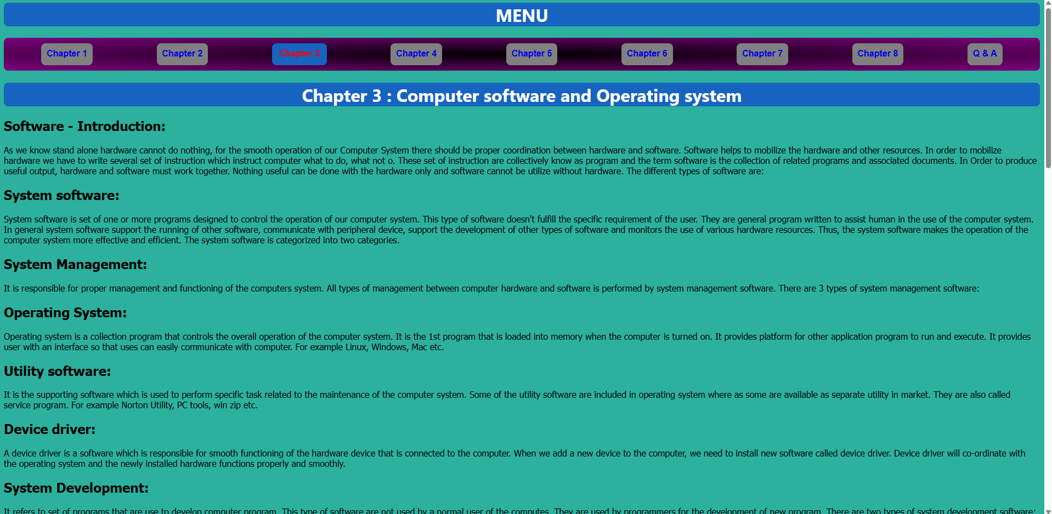**OUTPUT:**

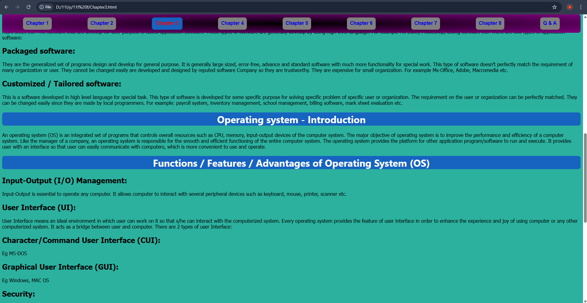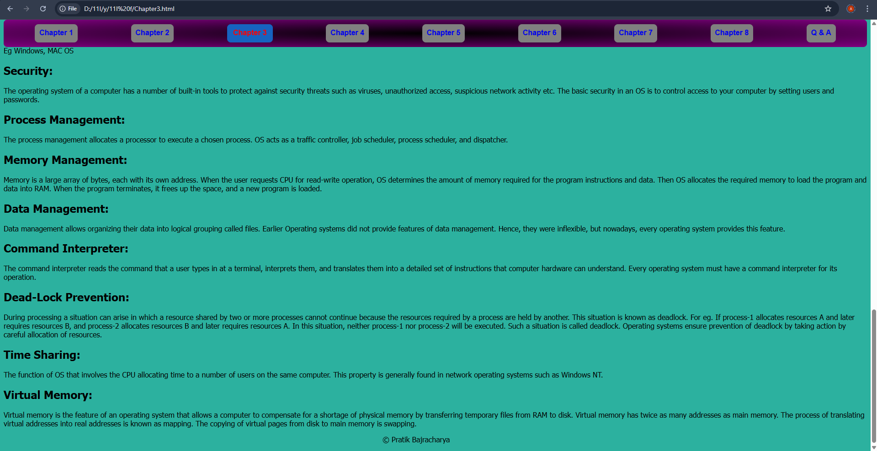

## File: chapter4.html

<html>

    <head>

        <link rel="stylesheet" href="styl.css">

        <title>MENU</title>

    </head>

    <body><h1><div>MENU</div></h1>

        <nav>

            <a href="Chapter1.html">Chapter 1</a>

            <a href="Chapter2.html">Chapter 2</a>

            <a href="Chapter3.html">Chapter 3</a>

            <a href="#">Chapter 4</a>

            <a href="Chapter5.html">Chapter 5</a>

            <a href="Chapter6.html">Chapter 6</a>

            <a href="Chapter7.html">Chapter 7</a>

            <a href="Chapter8.html">Chapter 8</a>

        </nav>

        <div><h1>Chapter 4 : Application Software</h1></div>

<p><h2>MS-Word (Word Processor)</h2></p>

<p>Introduction: MS-Word is a text editing or word processing software developed by Microsoft Corporation, USA under the MS-Office package. Word processing refers to the use of computers to create, edit, and print documents. A word processor enables us to create a document, store it electronically in a disk, display it on a screen, modify it by entering commands and characters from the keyboard, and print it on a printer. MS-Word is a Windows-based application, and it has many powerful and advanced features to manipulate the document. With the help of this program, we can create any types of documents like letters, reports, thesis, manuals, brochures, advertisements, and many other documents. Besides creating, editing, and modifying documents, MS-Word provides some special facilities such as checking spelling and grammatical errors, searching for synonyms and antonyms, working with columns, tables, special symbols, pictures, graphs, charts, and many more. The document created with MS-Word has a “.doc” extension. The newer version of MS-Word has a newer extension “.docx”.</p>

<p><h2>Features of MS-Word</h2></p>

<p><strong>a. Fast operation:</strong> Since MS-Word is a digital text editing software, there is no mechanical movement associated. Hence, it is faster in operation.</p>

<p><strong>b. Editing text feature (Character formatting):</strong> Any type of operation like insert, delete, modify the documents, undo/redo, find/replace can be performed very easily. Similarly, we can customize our text document in any form or style like bold, italic, underline, different font size, different font color, different font style, etc.</p>

<p><strong>c. Permanent storage:</strong> Using MS-Word, files and documents can be electronically stored in a disk or any other storage medium. So, we can retrieve it whenever required.</p>

<p><strong>d. Graphics:</strong> MS-Word allows us to insert several objects like pictures and graphs anywhere in the document whenever required.</p>

<p><strong>e. OLE (Object Linking and Embedding):</strong> OLE is a technology used to share information between programs through objects. Objects are saved entities of different types like charts, equations, pictures, audio and video files, etc.</p>

<p><strong>f. Mail merge:</strong> Mail merge is a useful tool that will allow us to easily produce multiple letters, labels, envelopes, and more using information stored in a list, database, or spreadsheet.</p>

<p><strong>g. Searching:</strong> MS-Word allows us to search any word or text and replace or delete it with other necessary ones throughout the entire document.</p>

<p><strong>h. Printing:</strong> MS-Word allows users to print the documents created by the user anytime, anywhere.</p>

<p><strong>i. Formatting a document:</strong> Word has various tools to help format a document. Formatting refers to the process of enhancing the appearance of the document to make it more readable and attractive. We can search and replace, display a ruler, change paragraph alignment, change line spacing, create bullets and numbering to show information in a list. To further enhance the appearance of the text and documents, we can add borders and shading. We can even add a watermark to denote some confidential information in a document.</p>

<p><strong>j. Spelling and Grammar checker:</strong> MS-Word provides you with several features to help you produce professional and error-free documents. To make your document appear professional, you want to make sure it is free from spelling and grammar errors. Word also has the feature of checking grammatical and spelling errors and notifying users by different colored wavy lines, which may be red or green.</p>

<p><strong>k. Use of thesaurus:</strong> MS-Word's thesaurus makes it possible to look up synonyms and antonyms for words with a few clicks of the mouse. We can automatically replace a word with its respective antonyms or synonyms.</p>

<p><h2>MS-Excel (Spreadsheet)</h2></p>

<p>MS-Excel is a spreadsheet software in the Microsoft Office suite that allows users to store, organize, and analyze numerical and text data. It is a part of the MS-Office package. A spreadsheet program allows presenting information in a clear way. It can be used to perform mathematical calculations using several mathematical formulas and equations. Excel also allows us to convert spreadsheet data into various charts like bar graphs, columns, and others. It can be used to calculate data according to the needs of the user such as salary sheets, income and expense statements, balance sheets, budget preparation, grade and percentage calculations, etc. Some application areas of Excel are:</p>

<p>Basic mathematical calculation.</p>

<p>Financial modeling and analysis.</p>

<p>Statistical analysis.</p>

<p>Scientific and engineering calculation.</p>

<p>Graphic presentation and more.</p>

<p>The extension of MS-Excel file is “.xlsx” and “.xls”.</p>

<p><h2>Features of MS-Excel</h2></p>

<p>It facilitates us to work in multiple worksheets at a time.</p>

<p>It allows us to create different types of charts and graphs.</p>

<p>It allows us to organize and manage large volumes of data.</p>

<p>It allows us to perform any type of calculation automatically by using custom formulas and equations.</p>

<p>It allows us to easily sort the data in ascending and descending order.</p>

<p>It supports high-level features like object linking and embedding.</p>

<p>It allows us to format data to make it more attractive by using tools like font size, font color, etc.</p>

<p>Simple computing operations such as cut, copy, paste, find, and replace can be easily done.</p>

<p>It includes internet features such as the web toolbar.</p>

<p>It allows us to store data electronically in any storage medium.</p>

<p><h2>MS-PowerPoint (Presentation)</h2></p>

<p>PowerPoint is the presentation software in the Microsoft Office suite. With PowerPoint, we can create dynamic and professional presentations by using pre-defined layouts, themes, and templates. PowerPoint includes all the features we need to produce professional-looking presentations. A PowerPoint presentation consists of a series of slides which contain information that we want to communicate with our audience. This information can include text, images, graphs, charts, videos, audio, and many more. The presentation program can be used as a supplement to older visual aid technology such as pamphlets, handouts, posters, chalkboards, etc.</p>

<p>The extension of PowerPoint files is “.ppt”, and later versions use “.pptx”. Similarly, MagicPoint, Apple Keynote, IBM Lotus, Harvard Graphics, etc., are alternative software for MS-PowerPoint.</p>

<p><h2>Features of MS-PowerPoint</h2></p>

<p>Formatting of data helps to make the document much more attractive, effective, and interactive by using tools like font, font color, hyperlinks, etc.</p>

<p>Simple computing operations such as cut, copy, paste, find, and replace are supported.</p>

<p>It allows the user to use pre-defined layouts, themes, and templates, which helps in faster development and design of presentations.</p>

<p>Slide transitions and effects can also be used for further requirements.</p>

<p>We can create our own custom animations.</p>

<p>It supports both internal and external hyperlinks.</p>

<p>Different bars, graphs, and charts can be used to convey detailed and precise information.</p>

<p>Internet features such as the web toolbar, online help, and web linking can also be done.</p>

<p><marquee>&copy; Pratik Bajracharya</marquee></p>

</body>

</html>

**OUTPUT:**

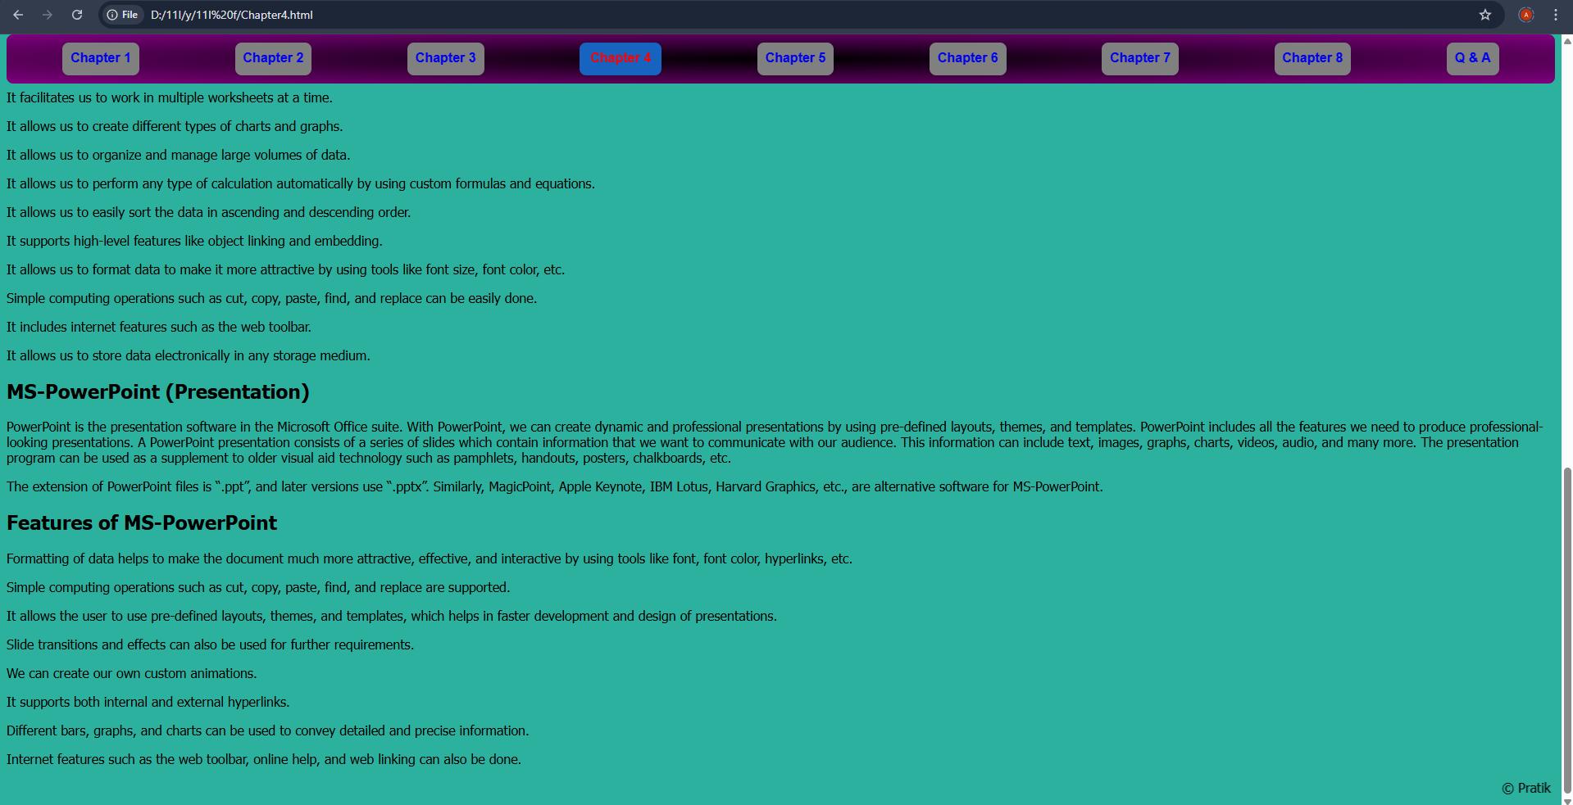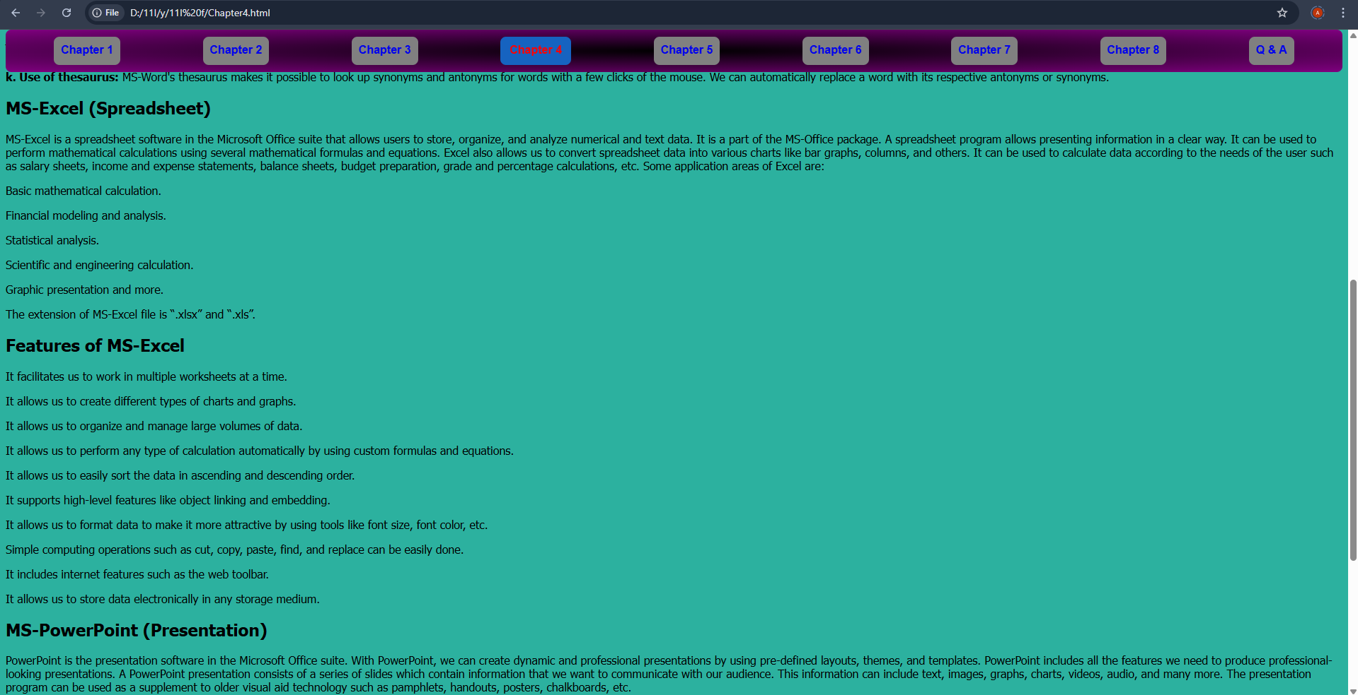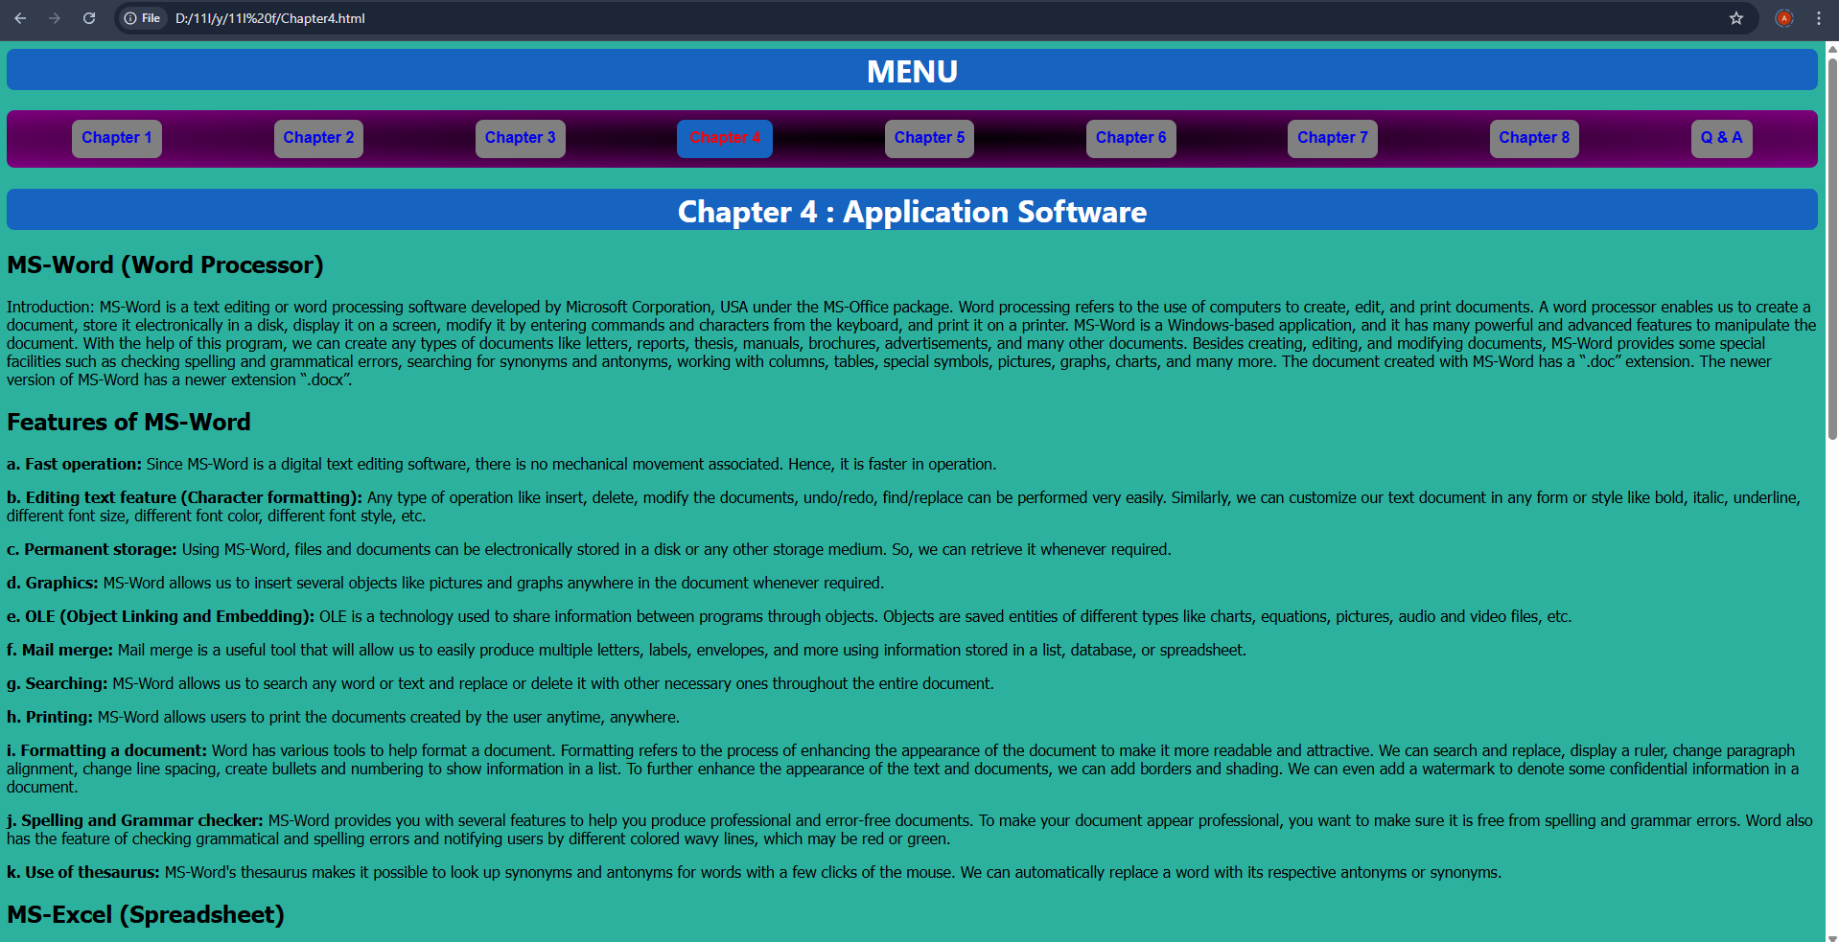

## File: chapter5.html

<html>

    <head>

        <link rel="stylesheet" href="styl.css">

        <title>MENU</title>

    </head>

    <body><h1><div>MENU</div></h1>

        <nav>

            <a href="Chapter1.html">Chapter 1</a>

            <a href="Chapter2.html">Chapter 2</a>

            <a href="Chapter3.html">Chapter 3</a>

            <a href="Chapter4.html">Chapter 4</a>

            <a href="#">Chapter 5</a>

            <a href="Chapter6.html">Chapter 6</a>

            <a href="Chapter7.html">Chapter 7</a>

            <a href="Chapter8.html">Chapter 8</a>

        </nav>

        <div><h1>Chapter 5 : Programming Concepts and Logics</h1></div>

<p><h2>Introduction:</h2></p>

<p>As we know, every computerized device does not work by itself. They need to be given some sort of command that makes the computer work. These commands help to instruct the computer and program specific actions required by the user. Since the commands are given in the form of a computer language, we need programming languages to write the set of instructions which command the computer to perform certain actions, collectively called programs. These programs are again integrated in order to make a complete software. Simply, software is the collection of different interrelated programs which perform specific functions.</p>

<p>Programs written in any type of programming language are not understood by the computer, hence we need some sort of language translator or processor such as assembler, compiler, and interpreter, which have the basic function of converting programs written in any type of language into machine-level language.</p>

<p>The program written by the programmer is known as the source program. After converting it becomes a program.</p>

<p><h2>Qualities of Good Programs:</h2></p>

<p>It should be easily understood.</p>

<p>A program should be correct; it should be error-free.</p>

<p>It should be reliable.</p>

<p>It should have an easily understandable user interface.</p>

<p>It should be portable and flexible.</p>

<p><h2>Programming Language:</h2></p>

<p>In order to make communication between the user and the computer, we need a computer language that helps the user to generate commands to perform as per the requirement. This language, with which we can give instructions to the computer, is known as a programming language. Programming languages are a set of different keywords, variables, operators, loops, and other entities using different character sets, including numbers, special symbols, and alphanumeric values.</p>

<p>Hence, the process of writing the programming language is known as programming, and the person who writes the program is called a programmer.</p>

<p><h2>Types of Programming Languages</h2></p>

<p>There are several types of programming languages which can be categorized as follows:</p>

<p><h3>1. Low Level Language:</h3></p>

<p>Low-level languages are machine-dependent languages, which means that a program written for one type of system cannot be run on another system. A developer should have a detailed analysis and knowledge about the system for which they are going to write a program. Hence, programming in low-level languages is very much difficult and time-consuming. Different types of programming languages are:</p>

<p><h4>a. Machine Level Language (1GL):</h4></p>

<p>This language consists of a sequence of 0's and 1's to generate instructions. Since it uses binary numbers, this type of language is directly understood by the processor. So, it has a higher execution speed. It is also a machine-dependent language in which programmers should have detailed knowledge of the system.</p>

<p><strong>Advantages:</strong></p>

<p>It is directly understood by the processor, so execution speed is relatively high.</p>

<p>Language translators or processors are not needed.</p>

<p>They can be used to program specific purpose computers.</p>

<p><strong>Disadvantages:</strong></p>

<p>It is difficult and time-consuming to develop and debug a program.</p>

<p>It is a machine-dependent language. So, a program developed for one system cannot be operated in another system.</p>

<p>All the syntax and commands are in the form of binary numbers, which is difficult to remember.</p>

<p>Programmers should have detailed knowledge about a particular system and its architecture.</p>

<p><h4>b. Assembly Language (2GL):</h4></p>

<p>Assembly language is also an example of low-level language. In this language, instead of writing instructions in the series of 0's and 1's, we can use mnemonics (symbolic instructions) like ADD, SUB, RST, DIV, MOD, and so on. Since it is closer to machine-level language, a programmer should have detailed knowledge about the computer's internal architecture. This language is faster in comparison to high-level language. Since this language is not directly understood by the computer, we need a language translator like an assembler to convert it into machine-level language.</p>

<p><strong>Advantages:</strong></p>

<p>It is easier to write, debug, and understand programming written in assembly language compared to machine-level language.</p>

<p>Program execution is faster compared to high-level language.</p>

<p>Since they are machine-dependent, they are used to develop different device drivers.</p>

<p><strong>Disadvantages:</strong></p>

<p>It is a machine-dependent language, i.e., a program made for one processor doesn’t run in another processor.</p>

<p>The use of mnemonics code makes assembly language much more complex.</p>

<p>Program development and debugging are more difficult and time-consuming compared to high-level language.</p>

<p><h3>2. High Level Language:</h3></p>

<p>This language is close to the English language. High-level language code is written in an English-like structure using mathematical notation. Since it is similar to the English language, it is easier to develop and debug the program. It is machine-independent (i.e., programs developed for one processor can work on another processor). Since HLL (High Level Language) is not directly understood by computers, we need a language processor or translator, such as a compiler and interpreter, to convert programs written in high-level language to machine-level language. FORTAN (Formula Translator), introduced in 1956, is the first high-level language. Nowadays, there are many high-level languages like C, C++, Python, JavaScript, etc.</p>

<p><strong>Advantages:</strong></p>

<p>Since it is closer to the English language, programs written in this language are easier to write, debug, and understand.</p>

<p>Since it is machine-independent, programs written for one processor can work on another processor.</p>

<p>Programmers don’t have to remember a large number of mnemonics and other unusual codes.</p>

<p>Program development is faster and requires less effort than other languages.</p>

<p><strong>Disadvantages:</strong></p>

<p>Computers don’t understand high-level language directly. So the program needs conversion before execution.</p>

<p>Program execution is slower compared to low-level language.</p>

<p><h2>High Level Language can further be classified into:</h2></p>

<p><h3>a. Procedural Oriented Language (3GL):</h3></p>

<p>This type of language is a high-level language that primarily focuses on procedures rather than on data. Hence, they are used to express the logic and procedure of the program. Since it focuses only on procedure, it is complex and time-consuming to write a large program. This type of language follows a top-to-bottom approach, i.e., the main function is written at the bottom of the program. This type of language doesn’t have important and powerful features like data encapsulation, data inheritance, data extraction, and so on. So, this type of language has less security compared to object-oriented language. Examples: C, FORTRAN, QBasic, etc.</p>

<p><strong>Advantages:</strong></p>

<p>Program development and debugging are easier compared to low-level language.</p>

<p>More advanced and user-friendly software can be developed.</p>

<p>It is also a machine-independent language.</p>

<p>It is used for general-purpose programming.</p>

<p><strong>Disadvantages:</strong></p>

<p>Language translator or processor is required to execute the program.</p>

<p>Program execution is slower.</p>

<p>Data security is less compared to other high-level languages.</p>

<p><h3>b. Problem/Object Oriented Language (4GL):</h3></p>

<p>This is the advanced form of high-level language which primarily focuses on data rather than procedure. It allows the user to specify what the output should be without describing all the details (i.e., procedure) of how the data should be manipulated. This type of language follows a bottom-up approach. That means all main functions are written at the bottom of the program, whereas classes and objects are described at the top of the program. Since it has several powerful features such as data encapsulation, data extraction, and inheritance, the data is more secure compared to procedural language. Examples: C#, C++, Java, etc.</p>

<p><strong>Advantages:</strong></p>

<p>Web-based applications and software can be developed.</p>

<p>More advanced and user-friendly software can be developed.</p>

<p>It is also machine-independent language.</p>

<p><strong>Disadvantages:</strong></p>

<p>Language translator is required to execute the program.</p>

<p>Program execution is slower.</p>

<p>It is difficult to develop hardware-oriented languages.</p>

<p><h3>c. Natural Language (5GL):</h3></p>

<p>Natural language uses simple statements of common communication language, where we could write statements that would look like normal sentences. It is still in the developing stage; computer scientists are working hard on developing such language. However, programming languages like PROLOG (Programming Logic) are currently in use. For example: instead of writing some unusual code, programmers would write: “Who are the salesmen who have sold more than 30,000 products last month?”</p>

<p><strong>Advantages:</strong></p>

<p>It will be easier to develop and debug the program.</p>

<p>It will also be machine-independent</p>

<p><marquee>&copy; Pratik Bajracharya</marquee></p>

</body>

</html>

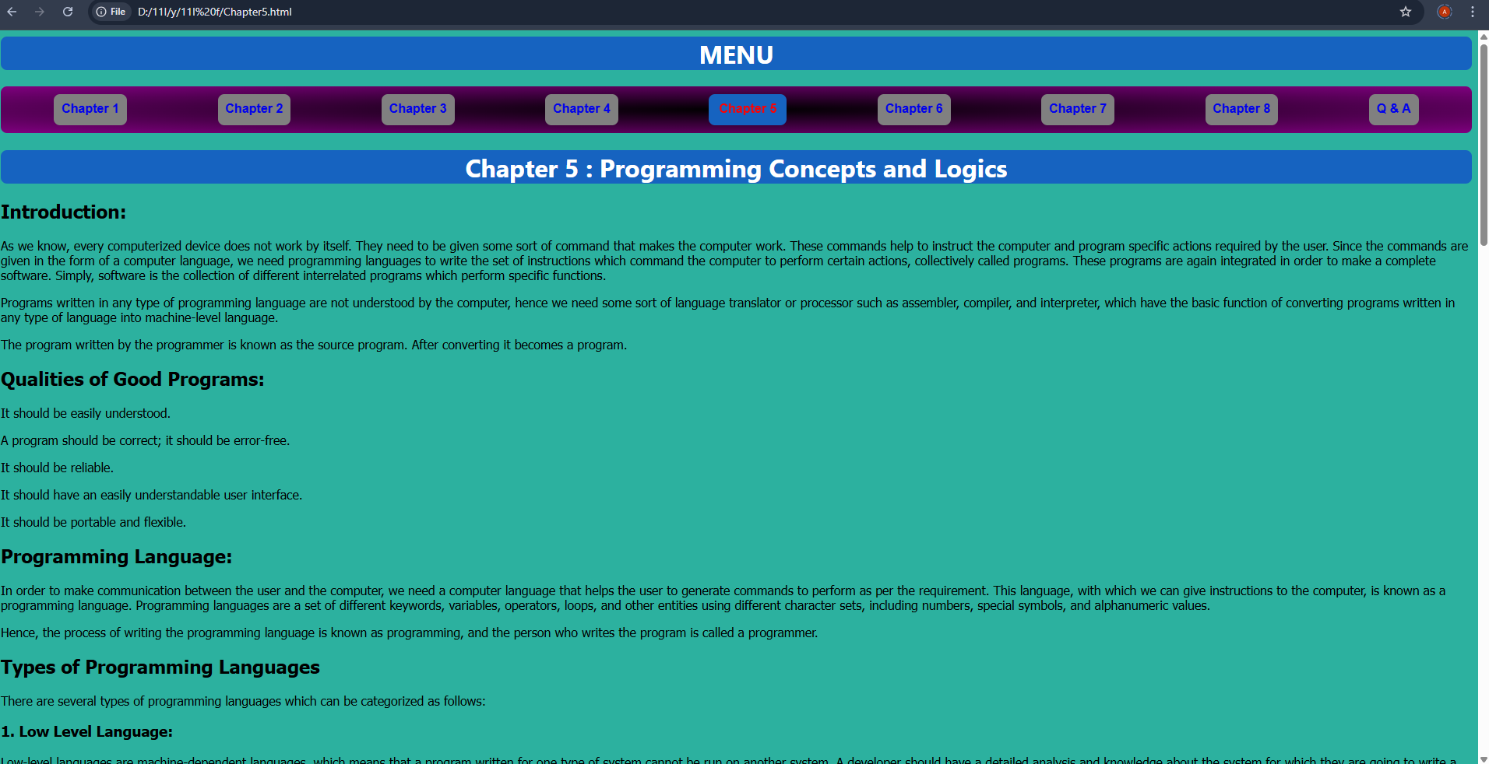OUTPUT:

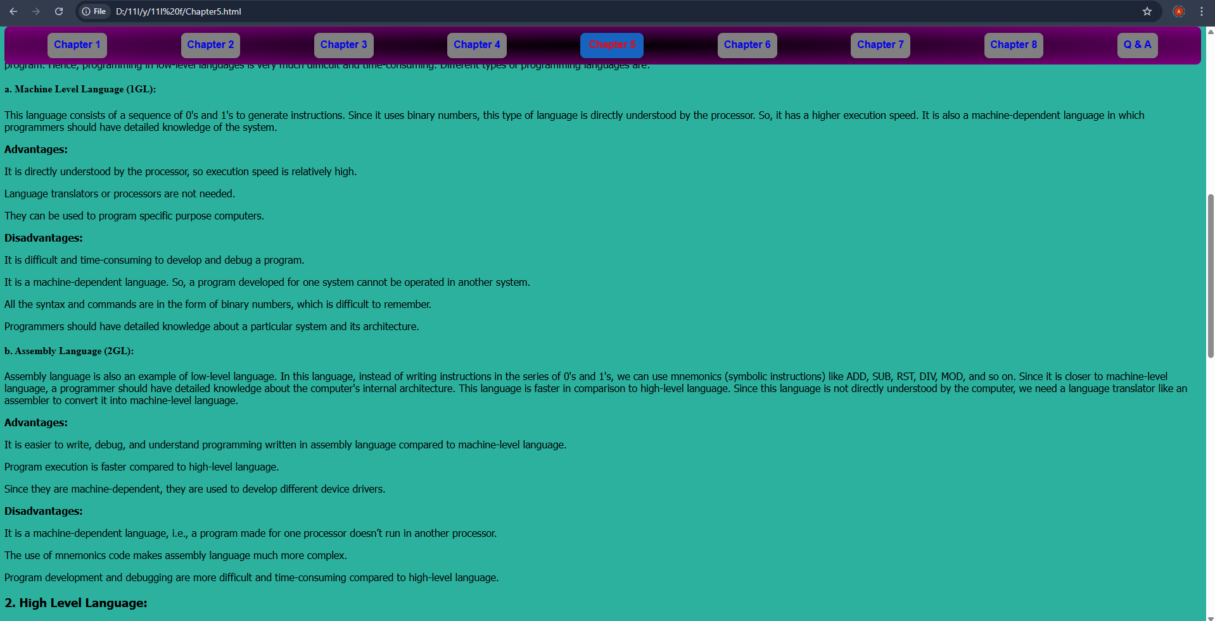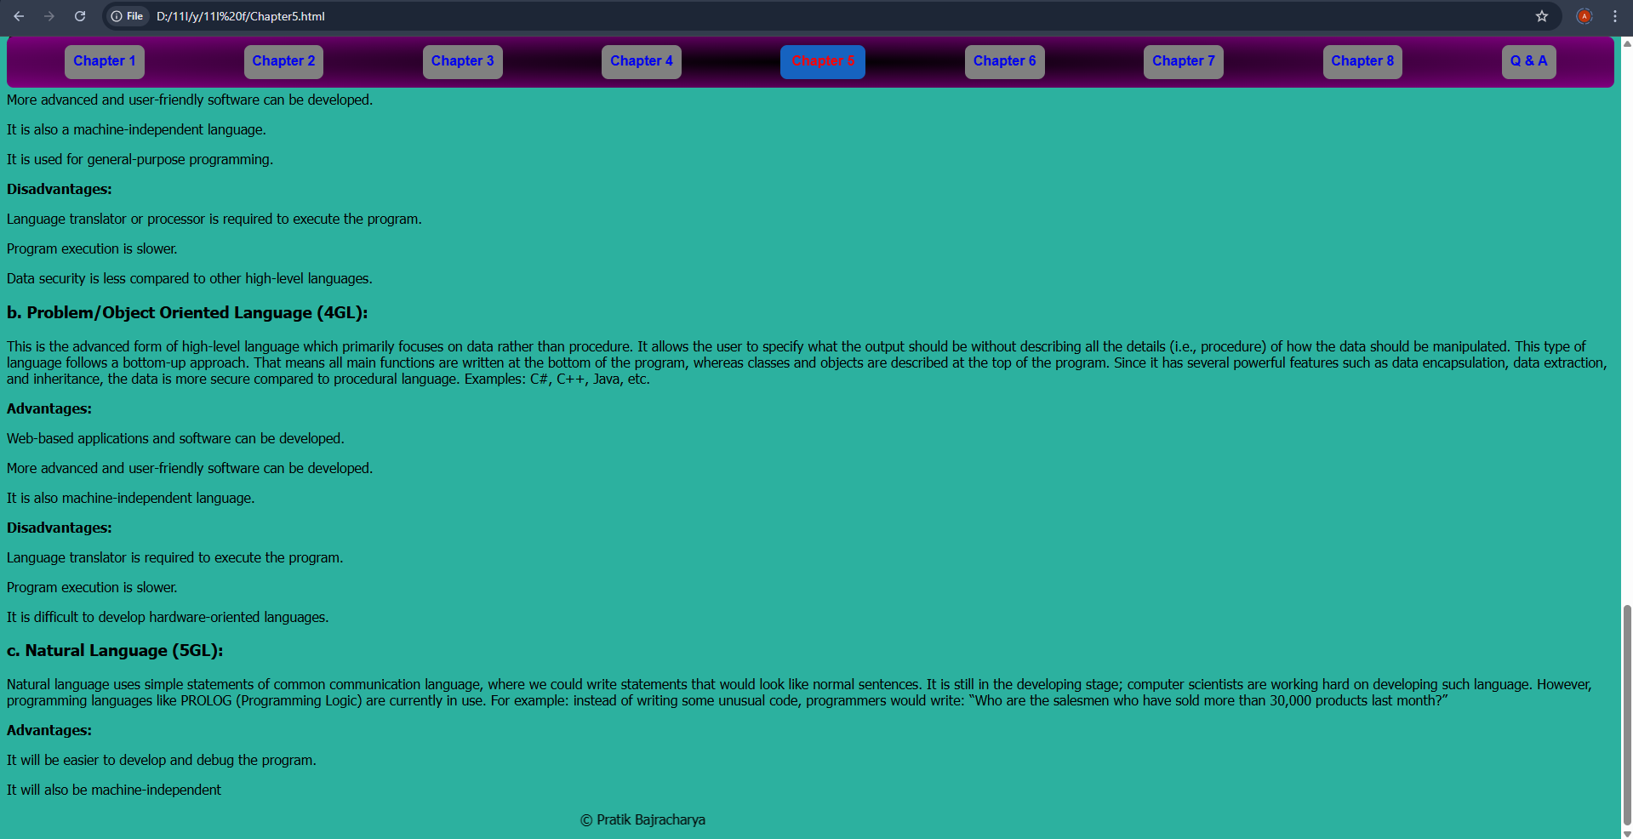

## File: chapter6.html

<html>

    <head>

        <link rel="stylesheet" href="styl.css">

        <title>MENU</title>

    </head>

    <body><h1><div>MENU</div></h1>

        <nav>

            <a href="Chapter1.html">Chapter 1</a>

            <a href="Chapter2.html">Chapter 2</a>

            <a href="Chapter3.html">Chapter 3</a>

            <a href="Chapter4.html">Chapter 4</a>

            <a href="Chapter5.html">Chapter 5</a>

            <a href="#">Chapter 6</a>

            <a href="Chapter7.html">Chapter 7</a>

            <a href="Chapter8.html">Chapter 8</a>

        </nav>

        <div><h1>Chapter 6 : Web Technology</h1></div>

<p><strong>Introduction to the Internet</strong></p>

<p>Internet is the global network of networks. Or it is a huge collection of computers all over the world that are inter-connected to one another in various ways to form a web-net.</p>

<p><strong>Components required for Internet Connections:</strong></p>

<ul>

    <li>A TCP/IP (Transmission Control Protocol/Internet Protocol) enabled computer with web browser.</li>

    <li>An account with an ISP (Internet Service Provider).</li>

    <li>A telephone line.</li>

    <li>A MODEM to connect to the telephone line and computer.</li>

    <li>A set of computer with the following capacity:

        <ul>

            <li>Minimum 386 microprocessor chip with 16 MB RAM.</li>

            <li>Color monitor with 256 color support and 640x480 resolution.</li>

            <li>A hard disk with 200 MB of free space.</li>

            <li>Multimedia sound card and speaker.</li>

        </ul>

    </li>

</ul>

<p><strong>Internet Services and Applications</strong></p>

<ul>

    <li><strong>World Wide Web (WWW):</strong> WWW is a series of services that are interconnected through hypertext. It was created in 1990 by the European Particle Physics Laboratory in Geneva, Switzerland, to exchange and share data through the Internet using the protocol known as Hypertext Transfer Protocol (HTTP).</li>

    <li><strong>Web Browser:</strong> A web browser is a computer program that accesses web pages and displays them on a computer screen. Popular web browsers include Internet Explorer, Safari, Mozilla Firefox, Opera, and others.</li>

    <li><strong>FTP - File Transfer Protocol:</strong> FTP is a tool that permits an Internet user to move or transfer a file from one computer to another. The files may contain data, graphics, text, etc.</li>

    <li><strong>Electronic Mail (E-mail):</strong> E-mail is the most widely used feature on the Internet for sending and receiving messages electronically, which can include a variety of digital text, graphics, video, animation, and audio data.</li>

    <li><strong>Voicemail:</strong> Voicemail is a service offered by specialized hardware and software that answers telephone calls and records audio messages.</li>

    <li><strong>USENET - View and News:</strong> USENET is the Bulletin Board Service (BBS) of the Internet, where messages are organized into thousands of newsgroups covering specific areas.</li>

    <li><strong>Chat:</strong> Chat is a service that allows real-time communication by typing. It is a quick and easy way to exchange information and ideas, with offline messages available if the person is not online.</li>

    <li><strong>IRC - Internet Relay Chat:</strong> IRC is a multi-user live chat facility. Major IRC servers around the world are linked, and anyone can create a channel to chat with others.</li>

    <li><strong>Video Conferencing:</strong> Video conferencing, also known as webcam chatting, enables direct face-to-face communication across networks and provides real-time visual communication.</li>

    <li><strong>Universal Resource Locator (URL):</strong> A URL is a unique address that identifies the location of a resource on the Internet. It consists of the protocol (http), host computer name (www), domain name (animalplanet), and domain type (com).</li>

    <li><strong>E-Fax (Electronic Fax):</strong> E-Fax allows sending and receiving faxes directly on a computer. It functions similarly to E-mail, where messages go to an Internet server and are then forwarded to the destination.</li>

</ul>

<p><strong>Introduction to HTML</strong></p>

<p>HTML stands for HyperText Markup Language, which is used to create web pages for the internet. HTML files are text files that contain several tags and attributes. It was developed by Tim Berners-Lee, based on SGML (Standard Generalized Markup Language). HTML uses these tags and attributes to organize and display content on a web browser. The versions of HTML include HTML, HTML+, HTML 1.0, HTML 2.0, HTML 3.2, HTML 4.01, and HTML 5.0.</p>

<p><strong>Use of HTML:</strong></p>

<ul>

    <li>It is used to create the basic layout or design of a web page.</li>

    <li>Without HTML, the worldwide web wouldn't exist.</li>

    <li>It allows embedding images, videos, audio, etc.</li>

    <li>It enables customization and formatting of characters, such as bold, italic, and underline.</li>

    <li>It helps create links and lists.</li>

</ul>

<p><strong>Advantages of HTML:</strong></p>

<ul>

    <li>It is easy to use, flexible, and user-friendly.</li>

    <li>It is supported by all web browsers and operating systems like Macintosh, Windows, Unix, etc.</li>

    <li>It is easy to obtain and modify content.</li>

    <li>It is compatible with all search engines.</li>

    <li>HTML 5.0 introduces several new and advanced features.</li>

    <li>HTML files load quickly.</li>

    <li>Many tutorials are available for learning HTML.</li>

</ul>

<p><strong>Disadvantages of HTML:</strong></p>

<ul>

    <li>It is difficult to create attractive and interactive web pages only with HTML. Other technologies like PHP, JavaScript, and SQL are often required.</li>

    <li>It cannot create dynamic web pages.</li>

    <li>It is a markup language, not a programming language.</li>

    <li>There are many inconsistencies and compatibility issues with HTML.</li>

    <li>There is no fully accepted standard for HTML.</li>

</ul>

<p><strong>HTML Tags</strong></p>

<p>HTML tags are instructions or commands given to the web browser to organize text, images, and other components of web pages. These tags are executed by the web browser to render content. Tags are written inside angular brackets &lt;&gt;. There are two types of HTML tags: opening tags and closing tags.</p>

<p><strong>DBMS (Database Management System)</strong></p>

<p><strong>Data:</strong> Data refers to raw facts and figures. They are isolated and uninterpreted until processed. For example, Ram, 19, 12, Pokhara.</p>

<p><strong>Information:</strong> Information is the meaningful result obtained after processing data. For example, "Ram is a student, 19 years old, who lives in Pokhara-12."</p>

<p>Databases are organized collections of data, designed to store and process information quickly and efficiently. A Database Management System (DBMS) helps manage this data. Examples include MS Access, MySQL, Oracle, and dBase.</p>

<p><strong>Advantages/Features/Importance of DBMS:</strong></p>

<ul>

    <li>Quick and easy data retrieval.</li>

    <li>Reduces data redundancy.</li>

    <li>Allows data sharing over a network.</li>

    <li>Improves data security and privacy.</li>

    <li>Helps reduce data inconsistency.</li>

    <li>Provides an organized way to store data.</li>

</ul>

<p><strong>Disadvantages of DBMS:</strong></p>

<ul>

    <li>Higher installation and operating costs.</li>

    <li>Requires more disk space.</li>

    <li>Potential security and privacy issues.</li>

    <li>Requires technical manpower (DBA) for maintenance and operation.</li>

</ul>

<p><marquee>&copy; Pratik Bajracharya</marquee></p>

</body>

</html>

**OUTPUT:**

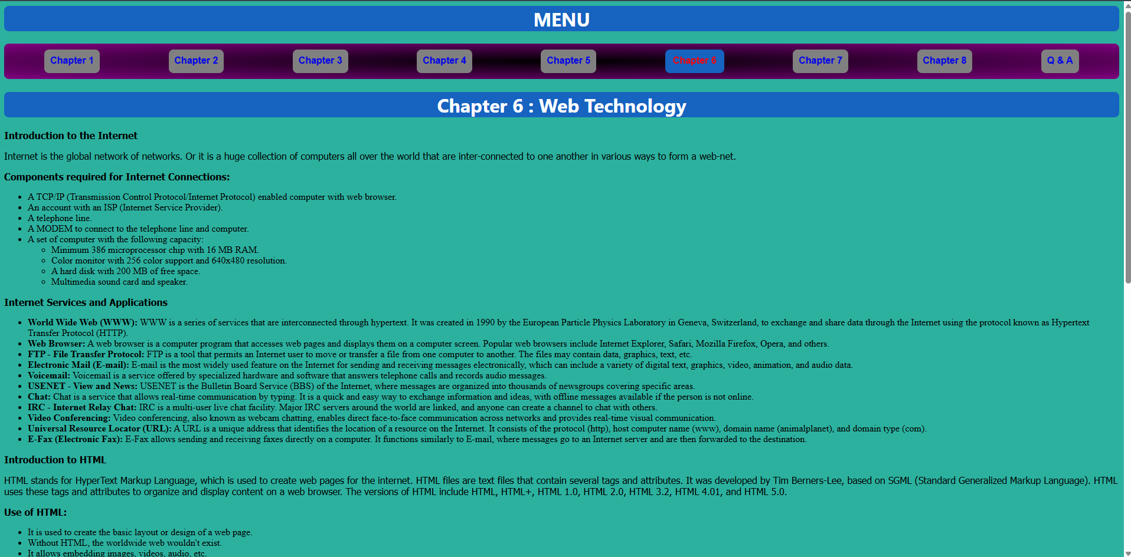

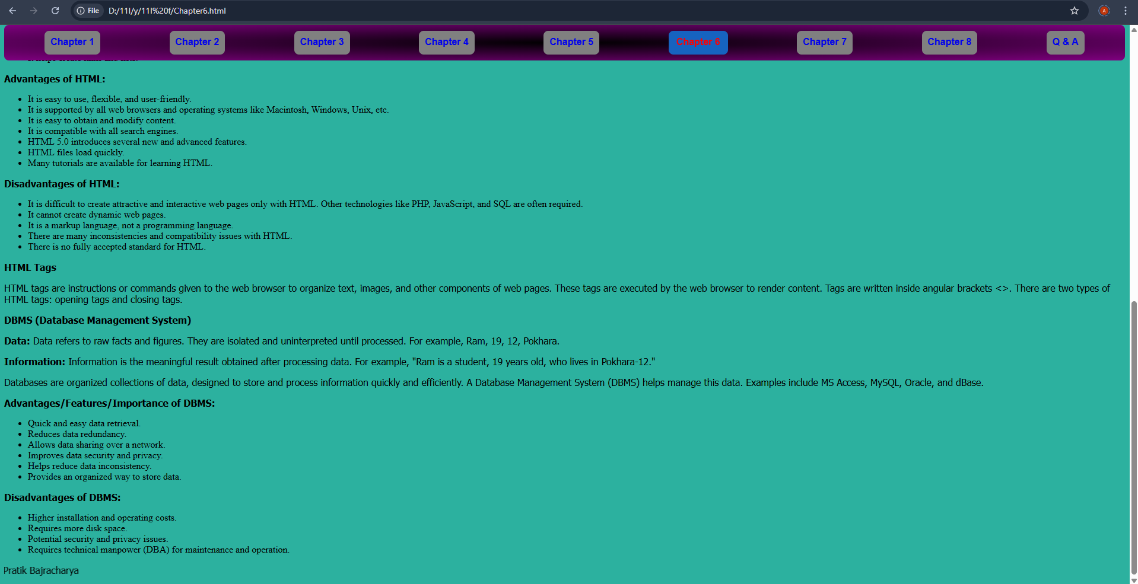

## File: chapter7.html

<html>

    <head>

        <link rel="stylesheet" href="styl.css">

        <title>Chapter 7</title>

    </head>

    <body><h1><div>MENU</div></h1>

        <nav>

            <a href="Chapter1.html">Chapter 1</a>

            <a href="Chapter2.html">Chapter 2</a>

            <a href="Chapter3.html">Chapter 3</a>

            <a href="Chapter4.html">Chapter 4</a>

            <a href="Chapter5.html">Chapter 5</a>

            <a href="Chapter6.html">Chapter 6</a>

            <a href="#">Chapter 7</a>

            <a href="Chapter8.html">Chapter 8</a>

        </nav>

        <div><h1>Chapter 7 : Multimedia</h1></div>

<p><strong>Introduction:</strong> Multimedia consists of two words: ‘Multi’ meaning many, and ‘Media’ meaning ways or mediums of expressing information. Hence, multimedia is a way of expressing information in different forms. Information can be expressed through text, audio, video, graphics, and animation. We use several forms of media for better understanding and effective communication. By using multimedia, any information can be illustrated in greater depth.</p>

<p>Since a single form of media is inefficient for better communication and understanding, we integrate several components of multimedia (text, audio, video, animation, and graphics) using multimedia computer systems. The integration of different forms of media is mandatory for effective communication. Multimedia computer systems consist of multimedia hardware and multimedia software. Examples of multimedia hardware include printers, projectors, webcams, microphones, and digital cameras. Multimedia software includes tools such as text editors (MS Word), presentation tools (PowerPoint), photo editing software (Photoshop), video editing software (iMovie), and accounting packages (Tally). These multimedia hardware and software work together to integrate several components of multimedia. For example, a video can be created by integrating audio and images.</p>

<p><strong>Advantages/Merits/Pros/Importance of Multimedia:</strong></p>

<ul>

    <li>It helps to make communication much more effective.</li>

    <li>It enhances the level of understanding of any particular topic.</li>

    <li>Games, cartoons, and movies are made more effective and realistic by using multimedia.</li>

    <li>It makes the teaching and learning process more interesting and intuitive.</li>

    <li>Virtual reality and simulation have become more realistic.</li>

</ul>

<p><strong>Disadvantages/De-merits/Cons/Limitation of Multimedia:</strong></p>

<ul>

    <li>Multimedia components may be expensive.</li>

    <li>Technical knowledge and IT literacy are required to operate multimedia.</li>

    <li>Technology is always changing and never constant.</li>

    <li>Multimedia devices require electricity to run.</li>

</ul>

<p><strong>Components/Elements of Multimedia:</strong></p>

<p><strong>Text:</strong> Text consists of alphanumeric values or characters. It can be a word, a line, or a paragraph. We can create and customize text using various text editors or word processors such as MS Word or Notepad. Text is the basic form of expressing information, and by using multimedia software, we can customize text with different sizes, colors, types, and styles. Common text document extensions are .docx, .txt, etc.</p>

<p><strong>Graphics / Images:</strong> "A picture is worth a thousand words," meaning that a picture can describe things better than text. Graphics generally refer to images or pictures. The smallest element of a picture is called a pixel (picture element). The quality of an image is denoted by the number of pixels available, which is known as the resolution. We use multimedia software such as Adobe Photoshop, Corel Draw, and Adobe InDesign to create and edit graphics. Image file extensions include .jpeg, .png, etc.</p>

<p><strong>Audio:</strong> Audio is one of the important components of multimedia as it provides the sensation of hearing. Audio can be used to enhance the understanding of any particular topic. Audio can be in the form of human voice, instrument notes, natural sounds, or digitally synthesized sounds. Today, audio can be transferred from one place to another by converting it into digital signals. FM radio stations use audio to express their information. Multimedia software such as Windows Media Player can be used to play audio. Audio file extensions include .mp3, .wma, etc.</p>

<p><strong>Video:</strong> Video consists of a series of frames (static pictures) captured in rapid succession. The quality of a video is determined by the number of frames per second (FPS), with typical standards being 15-25 FPS for smooth video, although 30 FPS and 60 FPS are also widely used in various devices. Multimedia software such as iMovie, Final Cut Pro, and Filmora can be used to edit and customize videos. Video file extensions include .mp4, .mpeg, etc.</p>

<p><strong>Animation:</strong> Animation is a sequence of computer-generated vector images displayed rapidly to create the illusion of motion. These images are created on computers and are used to express ideas, particularly when complex explanations need to be delivered effectively. Animation can be 2D or 3D, with 3D animations offering more realism. Animation is widely used in the movie and entertainment industries to depict scenes that are not feasible in real life. Multimedia software such as Maya Animation, AutoCAD, and Macromedia Flash can be used to create animations. Animation file extensions include .flv, .gif, etc.</p>

<p><strong>Applications of Multimedia:</strong></p>

<ul>

    <li>Education</li>

    <li>Communication</li>

    <li>Entertainment</li>

    <li>Medicine</li>

    <li>Science and Technology</li>

    <li>Advertisement</li>

    <li>Websites/Webpages</li>

    <li>Research and Engineering</li>

</ul>

<p><marquee>&copy; Pratik Bajracharya</marquee></p>

</body>

</html>

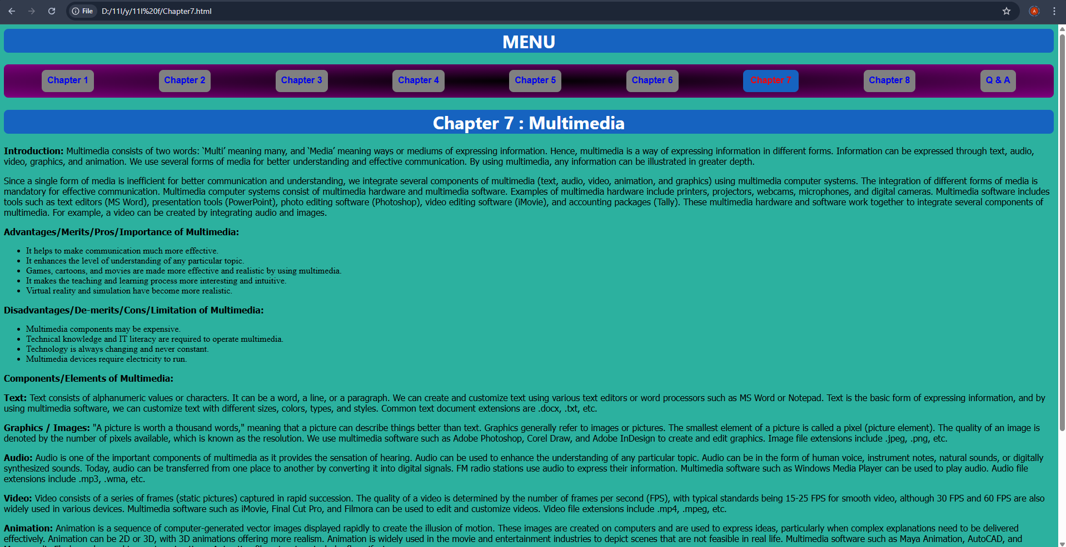**OUTPUT:**

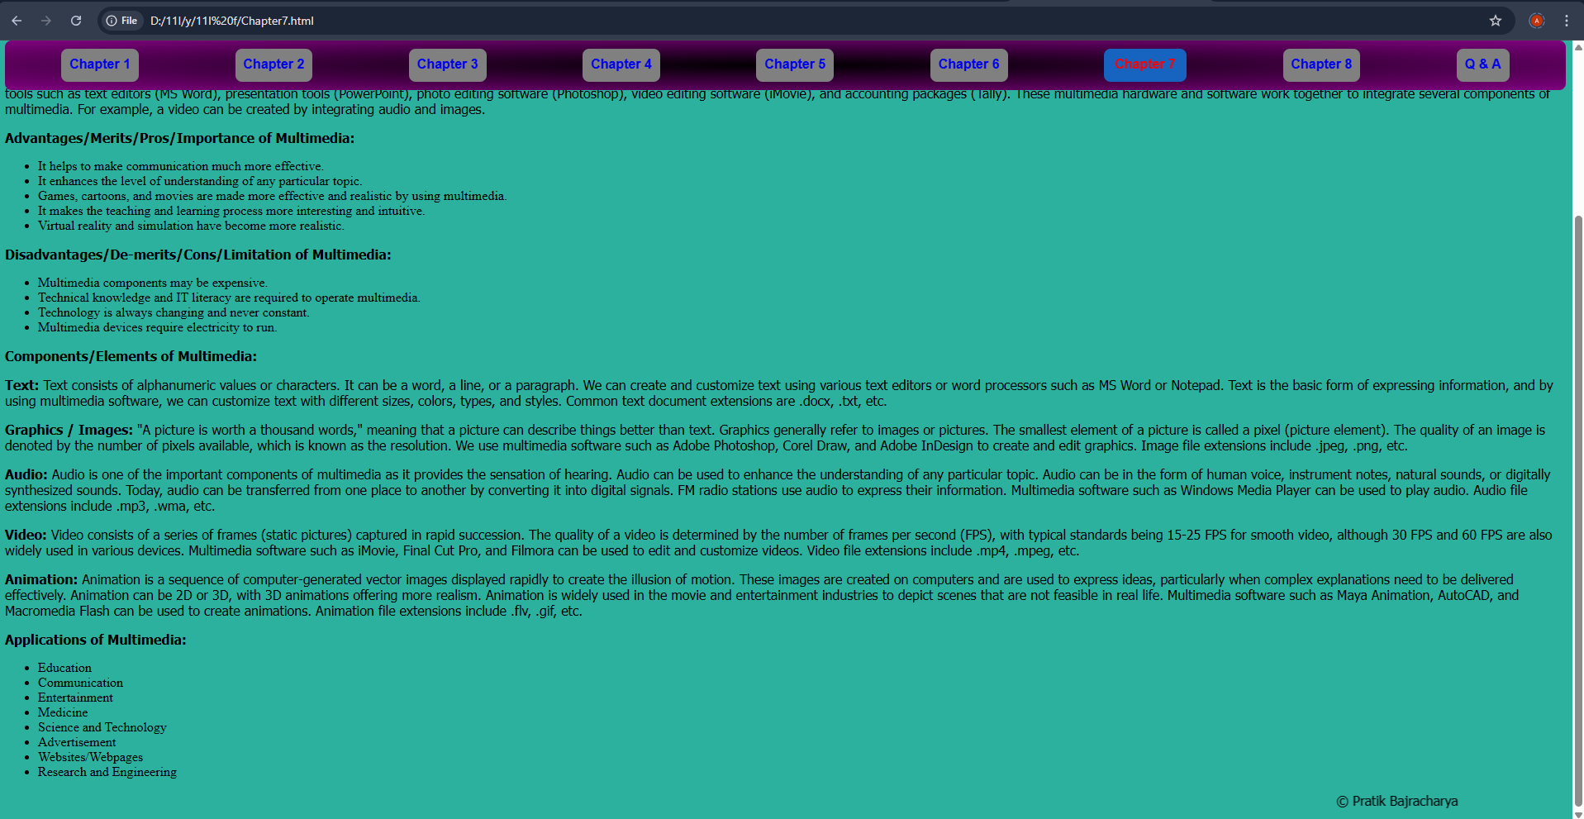

## File: chapter8.html

<html>

    <head>

        <link rel="stylesheet" href="styl.css">

        <title>Chapter 8 </title>

    </head>

    <body><h1><div>MENU</div></h1>

        <nav>

            <a href="Chapter1.html">Chapter 1</a>

            <a href="Chapter2.html">Chapter 2</a>

            <a href="Chapter3.html">Chapter 3</a>

            <a href="Chapter4.html">Chapter 4</a>

            <a href="Chapter5.html">Chapter 5</a>

            <a href="Chapter6.html">Chapter 6</a>

            <a href="Chapter7.html">Chapter 7</a>

            <a href="#">Chapter 8</a>

        </nav>

        <div><h1>Chapter 8 : Information Security and Cyber Law</h1></div>

<h2>Information Technology</h2>

<p>Information Technology (IT) is a modern concept or methodology of communication. It is a combination of Information and Communication Technology, which is extensively used for information flow and many other fields. IT has brought the world closer day by day, allowing us to send and receive messages across the globe in seconds. It is widely used in education, industry, banks, research centers, hospitals, and more.</p>

<p>In education, IT has become an essential tool for both learning and teaching, making distant learning possible. In industries, IT helps control the quantity and quality of products. It is also highly beneficial in hospitals, aiding in patient management and treatment. In entertainment, IT plays a vital role in animation and other media sectors. Additionally, scientists rely on IT for research and experiments, and space technology has become possible due to IT advancements. Thus, IT has a significant positive impact on society.</p>

<p>However, there are some negative aspects to IT. As its use increases, so does the prevalence of cybercrimes. Cybercriminals can steal data, expose confidential information, spread viruses, and disrupt networks, thereby affecting social peace and security.</p>

<h2>Information Security</h2>

<p>In a network or cyberspace, there is always the threat of cyberattacks that may lead to the loss or damage of valuable data and information. It is essential to be aware of such malicious activities and take measures to protect ourselves. Information security refers to the process of safeguarding our network infrastructure from unauthorized access, misuse, modification, destruction, or any malfunction.</p>

<p>We can use both physical and software preventive measures to protect ourselves from unethical activities. Information security helps create a secure environment for computers, users, and programs. It aims to mitigate security threats and attacks. A security threat is a possible danger that may cause unwanted activities, leading to a breach of security, while a security attack is an attempt to gain unauthorized access to, destroy, expose, steal, or alter valuable data and information. These attacks can be triggered by malicious applications such as viruses, spyware, Trojan horses, worms, etc.</p>

<p>Information security is built around three major objectives:</p>

<ul>

    <li><strong>Confidentiality:</strong> Information should only be available to authorized individuals, meaning that no one can access or process another's information without proper authorization.</li>

    <li><strong>Integrity:</strong> The accuracy and completeness of data and information must be maintained, meaning unauthorized individuals cannot tamper with data.</li>

    <li><strong>Availability:</strong> Information must always be available as needed, ensuring valuable data and information can be accessed whenever required.</li>

</ul>

<h2>Cryptography</h2>

<p>The term "cryptography" is derived from the Greek word meaning "secret writing." Cryptography is the art and science of securing information. It is primarily used to ensure secure communication between individuals, government agencies, and military forces.</p>

<p>Cryptography mainly involves encryption and decryption. Encryption is the process of converting plaintext (a readable message) into an unreadable format to prevent unauthorized access. The original message is transformed into unreadable text using special algorithms and keys. The unreadable text is called ciphertext. Decryption is the reverse process, converting the ciphertext back into its original, readable form.</p>

<p>Sometimes, encryption is also referred to as encoding or enciphering, and decryption is called decoding or deciphering.</p>

<p><marquee>&copy; Pratik Bajracharya</marquee></p>

</body>

</html>

**OUTPUT:**

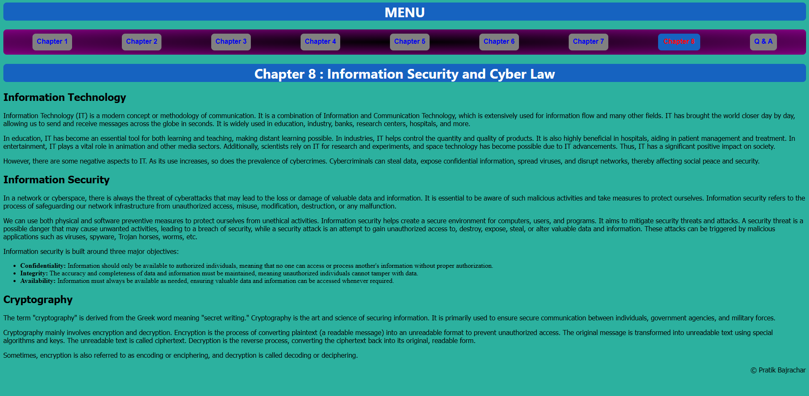

## File: Question & Answers.html

<html>

    <head>

        <link rel="stylesheet" href="styl.css">

        <style>

        </style>

        <title>MENU</title>

    </head>

    <body><h1><div>MENU</div></h1>

        <nav>

            <a href="Chapter1.html">Chapter 1</a>

            <a href="Chapter2.html">Chapter 2</a>

            <a href="Chapter3.html">Chapter 3</a>

            <a href="Chapter4.html">Chapter 4</a>

            <a href="Chapter5.html">Chapter 5</a>

            <a href="Chapter6.html">Chapter 6</a>

            <a href="Chapter7.html">Chapter 7</a>

            <a href="Chapter8.html">Chapter 8</a>

            <a href="#" id="QA">Q & A</a>

        </nav>

        <h1><div>Question and Answers</div></h1>

        <h3>1. What challenges are we facing to create a digital society in the Nepalese context?</h3>

           <p> The problems we are facing are:Lack of digital literacy,

            Inadequate internet infrastructure,

            Cybersecurity threats,

            High cost of digital devices and

            Resistance to change.</p>

            <h3> 2. What is computer ethics? What are the commandments of computer ethics?</h3>

        <p> Computer ethics refers to moral guidelines that governs the use of all computers.

            Commandments of Computer Ethics are as follow:<br>

            Do not use a computer to harm others.<br>

            Do not interfere with others computer work.<br>

            Do not snoop around in others files.<br>

            Do not use a computer to steal.<br>

            Do not use a computer to spread false information.</p>

        <h3>3. Discuss the role of computer ethics in the formation of a secure and reliable digital society.</h3>

        <p>It Prevents cybercrimes<br>

            Encourages responsible digital behavior<br>

            Protects privacy and data security<br>

            Promotes fairness and honesty in online interactions</p>

        <h3>4. Explain the basic principles/components of information security.</h3>

        <p>Confidentiality; Prevents unauthorized access to data.<br>

            Integrity; Ensures data accuracy and reliability.<br>

            Availability; Ensures authorized users have access to data.<br></p>

        <h3> 5. Define cyber law. What are the major fields of cyber law?</h3>

        <p>Cyber law is a legal framework that governs the use of the internet and digital activities.<br>

            Its Major fields are:

            Cybercrime laws,

            Intellectual property laws,

            Data protection and privacy laws,

            Electronic transaction laws.</p>

        <h3> 6. How do you know that your computer has been a victim of a malware attack?</h3>

        <p> Slow computer performance,

            Frequent crashes and system errors,

            Unexpected pop-ups and ads,

            Unauthorized changes in files,

            High data usage.</p>

        <h3> 7. How can you protect yourself and your computer system from cybercrime?</h3>

        <p> Use strong passwords,

            Install antivirus software,

            Keep software updated,

            Avoid clicking on suspicious links,

            Enable two-factor authentication.</p>

        <h3>8. What are the advantages and disadvantages of digital signature?</h3>

        <p> Advantages are:

            Ensures document authenticity,

            Provides legal validity,

            Saves time and cost. <Br>

            Disadvantages are:

            Requires internet access,

            Risk of hacking,

            Dependence on cryptographic technology.</p>

        <h3> 9. Explain various areas that are generally covered in cyber law.</h3>

        <p> Cybercrimes are:

            Data protection,

            Online transactions,

            Intellectual property rights,

            Social media regulations.</p>

        <h3> 10. Explain cyber law in Nepal with major provisions included.</h3>

        <p> It is Governed by the Electronic Transactions Act 2063 (2006),

            Defines cybercrimes and their penalties,

            Protects our digital transactions,

            Establishes rules for digital signatures.</p>

        <h3> 11. List out the major objectives of ICT Policy 2072.</h3>

        <p>The major objectives are: Promote digital literacy,

            Enhance cybersecurity,

            Expand internet access,

            Encourage e-governance,

            Support IT-based industries.</p>

            <h3>Long Answer Questions</h3>

            C. Long Answer Questions

        <h3>1. Explain at least ten activities that are considered as cybercrime.</h3>

        <p>Hacking: Gaining unauthorized access to a computer system or network.<br>

            Identity Theft: Stealing someone's personal information to commit fraud.<br>

            Phishing: Sending fraudulent emails or messages to trick users into providing sensitive information.<br>

            Cyberstalking: Harassing, threatening, or tracking someone online.<br>

            Data Theft: Stealing or leaking confidential data.<br>

            Online Fraud: Scamming people to steal money or personal information.<br>

            Ransomware Attacks: Infecting a system with malware that locks files and demands a ransom to unlock them.<br>

            Spreading Malware: Distributing malicious software like viruses, worms, or spyware.<br>

            Distributed Denial of Service (DDoS) Attacks: Overloading a website or network with massive traffic to make it unavailable.<br>

            Child Exploitation and Cyber Pornography: Creating, sharing, or possessing illegal content involving minors.</p>

        <h3>2. What do you mean by malicious software? Explain any ten malicious software attacks.</h3>

        <p>Malicious software (malware) is a program designed to harm or exploit digital systems.

        Examples of Attacks:

        Virus: Infects files and spreads across systems.

        Trojan Horse: Disguised as legitimate software to steal data.

        Ransomware: Encrypts files and demands payment for decryption.

        Spyware: Secretly collects user information.

        Adware: Displays unwanted ads and tracks user activity.

        Keyloggers: Records keystrokes to steal passwords.

        Worms: Self-replicating malware that spreads across networks.

        Rootkits: Hides malicious processes from the operating system.

        Botnets: Network of infected devices controlled by hackers.

        Logic Bombs: Malicious code triggered by specific conditions.</p>

        <h3>3. Explain intellectual property along with its types in detail. What legal provisions do we have in Nepal to preserve intellectual property rights?</h3>

        <p>Intellectual property (IP) refers to creations of the mind, such as inventions, literary works, and symbols.

        Types of Intellectual Property:<br>

        Copyright: Protects books, music, and software.<br>

        Patent: Grants rights for new inventions.<br>

        Trademark: Protects brand names and logos.<br>

        Trade secrets: Protects confidential business information.<br>

        Legal Provisions in Nepal:<br>

        Copyright Act 2059 – Protects creative works.<br>

        Patent, Design, and Trademark Act 2022 – Safeguards inventions and brands.</p>

        <h3>4. Explain digital signature along with its working mechanism.</h3>

        <p>A digital signature is an encrypted electronic signature that verifies the authenticity of digital documents.

        Working Mechanism:<br>

        Uses cryptographic algorithms.<br>

        A unique private key generates the signature.<br>

        The recipient verifies it using the sender’s public key.<br>

        Ensures document integrity and authentication.</p>

        <h3>5. Explain any ten policies included in ICT Policy 2072.</h3>

        <p>E-Governance Policy: Encourages digital services in government.<br>

        Cybersecurity Policy: Protects digital infrastructure.<br>

        ICT Infrastructure Development: Expands internet and technology access.<br>

        Digital Literacy Programs: Promotes ICT education.<br>

        E-Commerce Regulation: Establishes rules for online businesses.<br>

        Data Protection Law: Ensures privacy of digital data.<br>

        ICT Industry Promotion: Encourages IT-based industries.<br>

        Broadband Expansion Policy: Improves internet accessibility.<br>

        Innovation and Research Support: Encourages technological advancements.<br>

        Open Data Policy: Facilitates transparency in government information.</p>

        <p><marquee>&copy; Pratik Bajracharya</marquee></p>

    </body>

</html>

**OUTPUT:**

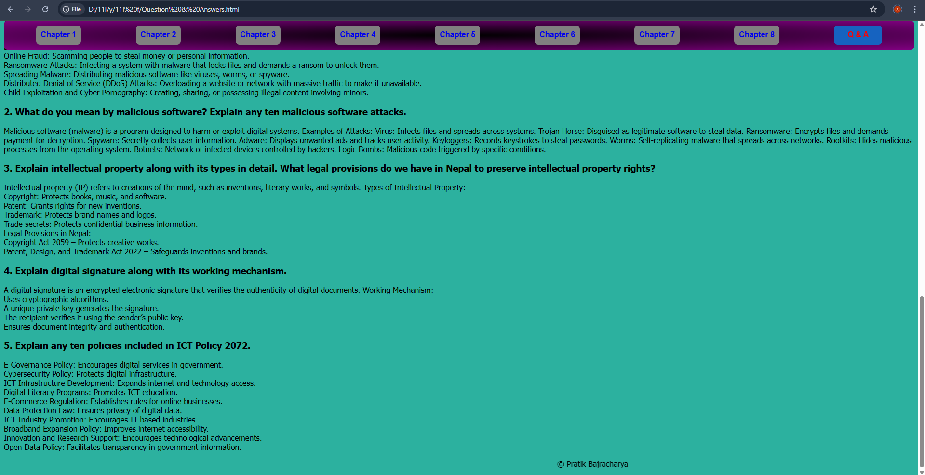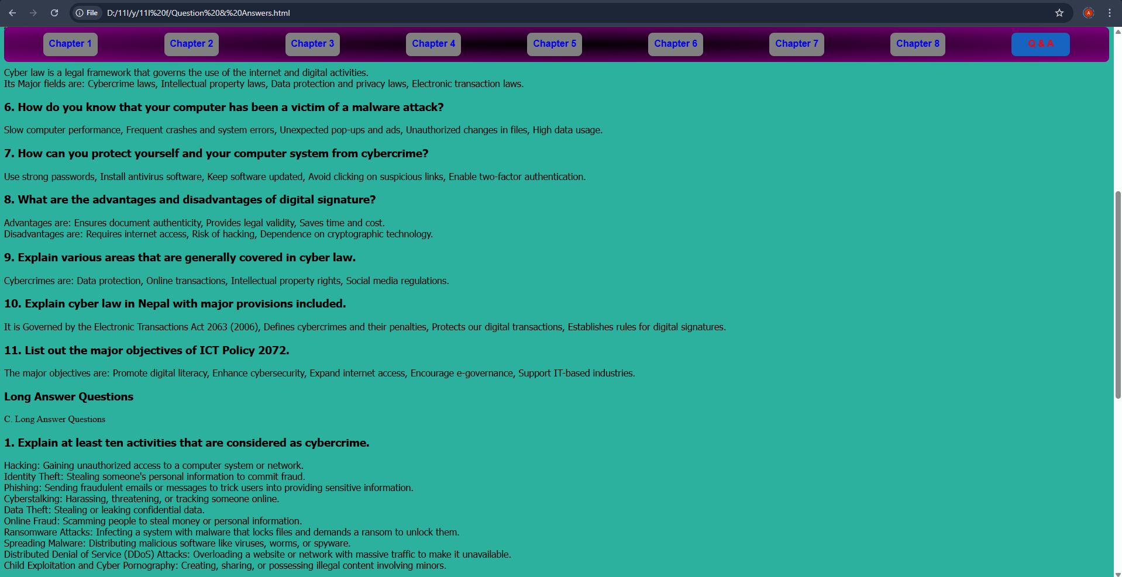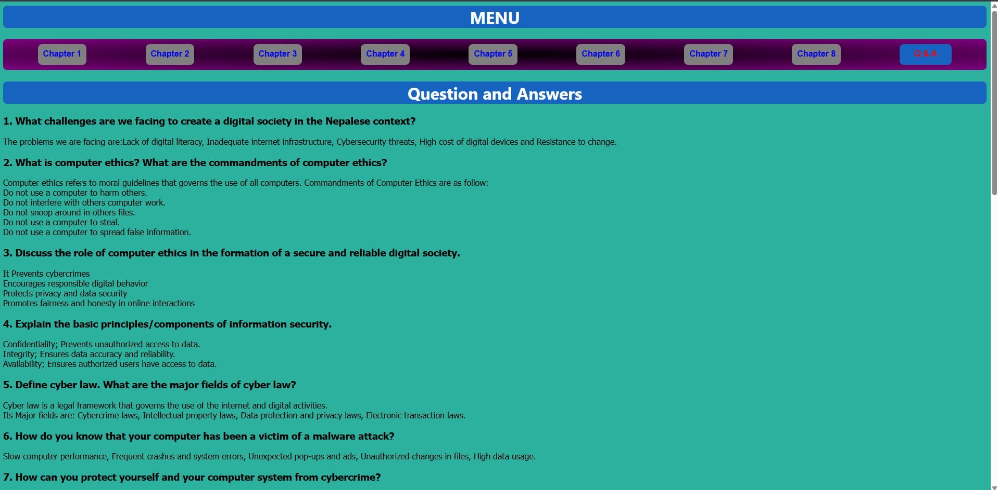

# CONCLUSION

Hence, from this report, I learned a lot about creating html files whilst linking them and compiling these webpages all into one website. Further, I learned how to externally add CSS to each and every webpage without having to make any extra effort through internal or inline CSS. Also, my knowledge of HTML and CSS have also been heightened by learning new types of tags, functions etc. In essence, I learned how to make a functioning nav bar linking to various webpages each with their own features and information.